ST.XAVIERS COLLEGE (AUTONOMOUS), KOLKATA



##### WEB PAGE DESIGN

##### ON

**NAVIGATION IN KOLKATA**

By

**Joshua Bahirvani (Roll: 3-15-12-0515 Reg.No: A01-1112-0742-12)**

**Nabanita Mondal (Roll: 3-15-12-0530 Reg.No: A01-2142-0751-12)**

**Kasturi Paul (Roll: 3-15-12-0536 Reg.No: A01-2112-0756-12)**

Under Guidance

Of

**Prof. Kaushik Goswami**

Submitted to the Department of Computer Science,

ST. XAVIER'S COLLEGE (AUTONOMOUS), KOLKATA,

in partial fulfilment of the requirements for the award of the degree,

B.Sc. Computer Science (Honours), Under University of Calcutta.

CERTIFICATE OF AUTHENTICATION

This is to certify that the project report entitled Web Page Design on Navigation in Kolkata submitted to **St. Xavier's College (Autonomous), Kolkata** in partial fulfilment of the requirement for the award of the degree of B.Sc. Computer Science (honours)**,** is an authentic and original work carried out under my guidance by:

Name Roll No. Registration No

1. Joshua Bahirvani 3-15-12-0515 A01-1112-0742-12
2. Nabanita Mondal 3-15-12-0530 A01-2142-0751-12
3. Kasturi Paul 3-15-12-0536 A01-2112-0756-12

The matter embodied in this project is genuine work done by the students and has not been submitted whether to this College or to any other University / Institute for the fulfilment of the requirements of any course of study.

-------------------------------------

-------------------------------------

------------------------------------- --------------------------------------

Signature of the Student(s) Signature of the Guide

Date: ……………….. Date: …………………

We hereby recommend that the project report prepared by **Joshua Bahirvani, Nabanita Mondal** and **Kasturi Paul** entitled **Web Page Design on Navigation in Kolkata**, be accepted in partial fulfillment of the requirements for the degree of B.Sc in Computer Science at St.Xaviers College (Autonomous), Kolkata.

------------------------------------- --------------------------------------

Signature of the H.O.D of Signature of External Guide

Computer Science

Date: ……………….. Date: …………………

**ACKNOWLEDGMENT**

We have received a lot of support from our respected principal Rev. Fr. Dr. John Felix Raj, S.J. and our respected Dean of Undergraduate Studies Dr.Tapati Dutta. All through the development phase of the project, Prof. Kaushik Goswami played a very important role in motivating us to make it a success. We are highly obliged to him for his guidance and constant supervision. We also had helpful discussions and suggestions from others, and above all lots of regard and hearty gratitude to our parents whose constant blessings and support is our chief sustenance to move ahead.

Thanks and appreciations to all those people who have willingly helped us with their best ability and knowledge.

Joshua Bahirvani

Nabanita Mondal

Kasturi Paul

#### CONTENTS

|  |  |
| --- | --- |
| CHAPTER | Page No. |
| **1. INTRODUCTION** |  |
| 1.1 BACKGROUND |  |
| 1.2 OBJECTIVE |  |
| 1.3 PURPOSE AND SCOPE |  |
| **2. SYSTEM ANALYSIS** |  |
| 2.1 IDENTIFICATION OF NEED |  |
| 2.2 PRELIMINARY INVESTIGATION |  |
| 2.3 FEASABILITY STUDY |  |
| 2.4 PROJECT PLANNING AND SCHEDULING |  |
| 2.5 SOFTWARE REQUIREMENT SPECIFICATION  2.5.1 NON FUNCTIONAL REQUIREMENTS  2.5.2 FUNCTIONAL REQUIREMENTS |  |
| 2.6 SURVEY OF TECHNOLOGIES |  |
| **3. SYSTEM DESIGN** |  |
| * 1. DATA MODELS      1. CONTROL FLOW DIAGRAM      2. DATA FLOW DIAGRAM      3. ENTITY RELATIONSHIP DIAGRAM |  |

#### 1

#### INTRODUCTION

As we all know, the key principle of Web accessibility is designing Web sites and software that are **flexible to meet different user needs**, **preferences**, and **situations**. It is an increasingly important resource in many aspects of life: **education, employment, government, commerce, health care, recreation**, and more. What if these advantageous properties of the web be infused into a site that would allow the user to get details about **traffic routes in a particular city**, so that while availing the transport he/she gets informed in advance about the **expenditures** related to it and **how far a certain destination is from any location**? Especially in a populous city like with dense traffic, this would be a favorable project that can be undertaken which would ease out the methods of navigation, mainly for people who are visiting for the first time.

**1.1** **BACKGROUND**

Navigation, in a broader sense, can refer to **any skill or study that involves the determination of position and direction**. In human navigation people visualize different routes in their minds to plan how to get from one place to another. The things which they rely on to plan these routes vary from person to person and are the basis of the differing navigational strategies. And over time navigation strategies have evolved to provide efficient direction finding methods, with respect to time as a major variable which has to be preserved.

In this project we take a different approach to this navigation strategy and build over it. With present technology revolution mapping and navigation have become exceptional and have helped many users. Now considering that the navigation and mapping system is in place, what will provide a better understanding of how the major public transport system functions with respect to one’s desired navigation goal? This is the question we asked and the project is initial steps to answer that problem of providing a complete navigation system.

Consider the city of Kolkata. With its huge area and multiple public transport options, anyone can get confused and not know how to reach his/her destination. People are helpful but errors do take place in giving transportation suggestions. So we thought **why not provide an on-the-go consulting tool that will help you to reach your desired location, while giving suggestions on the fare, bus numbers and on the side promote tourism in the City of Joy.**

##### 1.2 OBJECTIVE

The website is a tool which a user can apply to provide advice and suggestions to travel more efficiently using the public transport gaining **information about the bus or taxi fare, bus numbers going to the required destination , mapping solutions to see your route of travel and in the promote tourism for the city**. Our objective is to take a step to make navigation in the city **more efficient**.

* The main objective of this project is to create a consulting website that helps to find out **cost beneficial travelling routes** in the city of Kolkata by using the common modes of transportations (e.g. Buses, Taxis etc.) based on the **shortest distances** between the origin and the destination.
* Another main attribute would be **user-friendliness**, especially for tourists coming to the city, so that they can get the information about the **fares** for different public transports, distance between two places, which route to avail that would facilitate their navigation in the city and how they can carry out their sightseeing in a simplified manner.

**1.3 PURPOSE AND SCOPE**

1.3.1 PURPOSE

Let us consider a scenario of a person being new to the city. He/she leaves the airport with a taxi and specify a destination. Now it is up to the goodwill of the taxi driver to take the customer via the shortest path and not increase his meter bill by travelling on an inefficient route unnecessarily. But to be on the safe side the user can use the website and get a good estimate of the fare range he/she should expect and understand the route using the mapping scheme to know he is on the correct path.

1.3.2 SCOPE

The scope of the use of the website increases with Kolkata becoming a fully Wi-Fi enabled city thus making active data accessible to the user and providing complete web based solutions to the problems related to travelling in the city.

#### 2

#### SYSTEM ANALYSIS

**2.1 IDENTIFICATION OF NEED**

To get the accurate details about the expenditures required for travelling in various modes of transportation and the shortest routes between a certain pair of origin and destination well beforehand sounds quite advantageous than getting to know them on the go since it provides the customer some idea about the unprecedented time loss that may occur by not choosing the short routes and also the precise payment information. With the highly increased rate of web accessibility all over the world, a website providing all these facilities could definitely turn out to be useful, especially for tourists and non-residents of the city and also help promoting the tourism sector in Kolkata.

**2.2 PRELIMINARY INVESTIGATION**

* The shortest distance between the origin and destination is calculated from **Google Maps**, after that according to that distance, the average fare is calculated from the fare chart.
* Bus fares are calculated according to the basic knowledge of the programmers as regular passengers.
* Due to the limited scope of the project being made as an undergraduate course project, the chosen locations in the city of Kolkata are: **Maidan**, **Howrah Station**, **Kalighat**, **Dakshineswar**, **New Town, Sector V** and **Unitech/Rajarhat**.

**TAXI FARE CHART**

|  |  |  |
| --- | --- | --- |
| **Distance** | **AC Taxi (in Rs.)** | **General Taxi (in Rs.)** |
| 1 K.M. | 16 | 12 |

**BUS FARE CHART**

|  |  |
| --- | --- |
| Distance | General Bus (in Rs.) |
| 4 K.M. | 6 |
| 4-6 K.M. | 7 |
| 6-8 K.M. | 8-9 |
| 8-10 K.M. and above | 10 |

|  |  |
| --- | --- |
| Distance | AC Bus (in Rs.) |
| 4 K.M. | 20 |
| 4-10 K.M. | 30 |
| 10-14 K.M. | 40 |
| 14-20 K.M. | 50 |
| >20 K.M. | 60 |

**SHORTEST DISTANCES**

|  |  |  |
| --- | --- | --- |
| Origin | Destination | Distance (in K.M.) |
| Howrah Station | Kalighat | 12.6 |
| Howrah Station | New Town | 19.3 |
| Howrah Station | Dakshineswar | 11.5 |
| Howrah Station | Maidan | 4.5 |
| New Town | Kalighat | 22.5 |
| New Town | Dakhineswar | 17.7 |
| New Town | Maidan | 21.4 |
| Kalighat | Dakshineswar | 17.5 |
| Kalighat | Maidan | 4.9 |
| Dakshineswar | Maidan | 12.9 |
| Sector V | Maidan | 12.6 |
| Sector V | Howrah Station | 19.1 |
| Sector V | Kalighat | 13.6 |
| Sector V | Dakshineswar | 23.9 |
| Sector V | New Town | 12.8 |
| Sector V | Unitech,Rajarhat | 6.3 |
| Unitech,Rajarhat | Maidan | 20.4 |
| Unitech,Rajarhat | Howrah Station | 18.5 |
| Unitech,Rajarhat | Kalighat | 19.4 |
| Unitech,Rajarhat | Dakshineswar | 21 |
| Unitech,Rajarhat | New Town | 9.9 |

**2.3 FEASABILITY STUDY**

* All the data acquired are feasible in nature.
* The cost results being obtained from distance between two locations is an approximated value needed to give a more or less correct idea about it to the user.
* The map view being obtained from Google Maps obviously provides the correct information about the shortest route between a pair of origin and destination.
* Details about the tourist attractions are obtained from the internet and are kept as accurate as possible.

**2.4 PROJECT PLANNING AND SCHEDULING**

**GANTT CHART**: A **Gantt chart** is a type of bar **chart** that represents a project schedule. It illustrates the start and finish dates of the terminal elements and summary elements of a project. Each activity is represented as a bar in the calendar, starting from the starting date of activity and ending at the ending date for that activity.

|  |  |  |  |  |  |  |  |  |  |  |  |  |  |  |  |  |  |  |  |  |  |  |  |  |  |  |  |  |  |  |
| --- | --- | --- | --- | --- | --- | --- | --- | --- | --- | --- | --- | --- | --- | --- | --- | --- | --- | --- | --- | --- | --- | --- | --- | --- | --- | --- | --- | --- | --- | --- |
| S  T  A  G  E | ACTIVITIES | | MONTHS | | | | | | | | | | | | | | | | | | | | | | | | | | | |
| 10 | | | | 11 | | | | 12 | | | | 01 | | | | 02 | | | | 03 | | | | 04 | | | |
| 1 | 2 | 3 | 4 | 1 | 2 | 3 | 4 | 1 | 2 | 3 | 4 | 1 | 2 | 3 | 4 | 1 | 2 | 3 | 4 | 1 | 2 | 3 | 4 | 1 | 2 | 3 | 4 |
| 01 | **Preliminary Planning** | |  |  |  |  |  |  |  |  |  |  |  |  |  |  |  |  |  |  |  |  |  |  |  |  |  |  |  |  |
| 02 | **Training and basic implementation of web technologies** | |  |  |  |  |  |  |  |  |  |  |  |  |  |  |  |  |  |  |  |  |  |  |  |  |  |  |  |  |
|  | 2.1 | Analysis |  |  |  |  |  |  |  |  |  |  |  |  |  |  |  |  |  |  |  |  |  |  |  |  |  |  |  |  |
|  | 2.2 | Design |  |  |  |  |  |  |  |  |  |  |  |  |  |  |  |  |  |  |  |  |  |  |  |  |  |  |  |  |
|  | 2.3 | Testing |  |  |  |  |  |  |  |  |  |  |  |  |  |  |  |  |  |  |  |  |  |  |  |  |  |  |  |  |
| 03 | **Basic Implementation of code for output** | |  |  |  |  |  |  |  |  |  |  |  |  |  |  |  |  |  |  |  |  |  |  |  |  |  |  |  |  |
| 04 | **Implementing mapping API** | |  |  |  |  |  |  |  |  |  |  |  |  |  |  |  |  |  |  |  |  |  |  |  |  |  |  |  |  |
| 05 | **Interface and design of website** | |  |  |  |  |  |  |  |  |  |  |  |  |  |  |  |  |  |  |  |  |  |  |  |  |  |  |  |  |
| 06 | **Individual components testing** | |  |  |  |  |  |  |  |  |  |  |  |  |  |  |  |  |  |  |  |  |  |  |  |  |  |  |  |  |
| 07 | **Final Testing & Website complete** | |  |  |  |  |  |  |  |  |  |  |  |  |  |  |  |  |  |  |  |  |  |  |  |  |  |  |  |  |
| 08 | **Miscellaneous Activities** | |  |  |  |  |  |  |  |  |  |  |  |  |  |  |  |  |  |  |  |  |  |  |  |  |  |  |  |  |

|  |
| --- |
|  |
|  |

Actual time duration

Slack time duration

|  |  |  |
| --- | --- | --- |
| Preliminary planning | | |
| 1 | 76d | 20d |
| 1.10.2014 | 15.12.2014 | |

## **PERT CHART**: A PERT (Program Evaluation Review Technique) chart is a project management tool used to schedule, organize, and coordinate tasks within a project.

|  |  |
| --- | --- |
| Analysis | |
| 2.1 | 7d |
| 15.12.2014 | 21.12.2014 |

|  |  |  |
| --- | --- | --- |
| Training/Basic Implementation of web technologies | | |
| 2 | 29d | 4d |
| 15.12.2014 | 12.01.2015 | |

|  |  |
| --- | --- |
| Design | |
| 2.2 | 16d |
| 21.12.2014 | 05.01.2015 |

|  |  |
| --- | --- |
| Testing | |
| 2.3 | 8d |
| 05.12.2014 | 12.01.2015 |

|  |  |  |
| --- | --- | --- |
| Basic Implementation of code and output | | |
| 3 | 30d | 5d |
| 1.01.2015 | 01.02.2015 | |

|  |  |  |
| --- | --- | --- |
| Implementing mapping API | | |
| 4 | 50d | 15d |
| 22.12.2014 | 09.02.2015 | |

|  |  |  |
| --- | --- | --- |
| Interface and design of website | | |
| 5 | 49d | 15d |
| 25.01.2015 | 14.03.2015 | |

|  |  |
| --- | --- |
| Individual components design | |
| 6 | 7d |
| 06.03.2015 | 12.03.2015 |

|  |  |
| --- | --- |
| Final Testing and website complete | |
| 7 | 23d |
| 12.03.2015 | 04.04.2015 |

|  |  |
| --- | --- |
| Miscellaneous activities | |
| 8 | 28d |
| 15.03.2015 | 11.04.2015 |

|  |  |  |
| --- | --- | --- |
| Task Name | | |
| Task no. | Duration | Slack time |
| Start Date | End Date | |

The activities in PERT are placed with 3 types of estimates: **Optimistic, Likely** and **Pessimistic.**

|  |  |  |  |
| --- | --- | --- | --- |
| Processes | Optimistic | Likely | Pessimistic |
| 1.Preliminary planning | 70d | 96d | 100d |
| 2.Training/Basic Implementation of web technologies | 29d | 33d | 40d |
| 2.1.Analysis | 5d | 7d | 9d |
| 2.2. Design | 14d | 16d | 18d |
| 2.3. Testing | 6d | 8d | 10d |
| 3. Basic Implementation of code and output | 30d | 35d | 40d |
| 4. Implementing mapping API | 60d | 65d | 70d |
| 5. Interface and design of website | 60d | 64d | 68d |
| 6. Individual components design | 5d | 7d | 9d |
| 7. Final Testing and website complete | 20d | 23d | 26d |
| 8. Miscellaneous activities | 25d | 28d | 31d |

**2.5 SOFTWARE REQUIREMENT SPECIFICATION (SRS)**

2.5.1 NON-FUNCTIONAL REQUIREMENTS

**Product’s Requirements**:

* **Functionality requirements** - It is a capability of the software product to provide functions which meet the stated and implied needs when the software is used in specified conditions i.e. the basic functioning of the system based on the different user inputs is a preliminary requirement.
* **Efficiency requirements** - The system needs to provide appropriate performance when a user processes it and places a request in order to find the cost of using a certain transport between two places, or the shortest route between them, as fast as possible.
* **Reliability requirements** - The system must perform accurately towards a user request i.e. the user is ensured that the information that he/she gets is approximately correct and error-free. For e.g. be it the expenditure details or the route details, the data produced by the system should be reliable in nature.
* **Usability requirements** - The system must be user-friendly. It must have clear instructions to guide the user through the system while he/she operates it. Also if the user provides wrong data, an error message should be clearly given so that corrections can be done during the next accession procedure.
* **Maintainability requirements** – The system must be modifiable in the future i.e. more data and information about the different places and locations can be added based on which the cost and route finding processes can be modified in the system.

**Organizational Requirements:**

* **Implementation requirements** –
* The common Web-development languages (**XHTML, CSS, PHP, JavaScript**) are needed to construct the basic structure of the website that consists of for e.g. a framework that requires the user to set the source and destination, a page giving idea about the various famous tourist spots in the city etc. Certain basic algorithms are formulated that calculate the shortest route between two places, using these languages.
* An active **API (Application Program Interface)** is used to provide live transit routes to the website users which helps them to stay in view of the route.
* **Delivery requirements** – The whole system’s construction is completed in around 3 months’ time. The documentation is made in around 2 weeks. The system is to be delivered in a softcopy method while the documentation will be in both hardcopy and softcopy.

2.5.2 FUNCTIONAL REQUIREMENTS

From user’s perspective –

* The user needs to select a pair of origin and destination and choose a type of transport to get the expenditure details.
* User needs to select a tab to get information about various places of attraction located at different parts of the city.
* In order to view the shortest route via the map, user needs to enter the origin and destination of his choice.
* User can contact by using the mail id provided and give some feedback regarding the system.

**2.6 SURVEY OF TECHNOLOGIES**

The project being a web application requires sound and efficient tools to make it a well-oiled engine to perform in multiple scenarios.

**HTML** and **CSS** were obvious choices for constructing and styling the basic structure of the webpages.

**HyperText Markup Language**, commonly referred to as HTML, is the standard [markup language](http://en.wikipedia.org/wiki/Markup_language) used to create [web pages](http://en.wikipedia.org/wiki/Web_page).

* [Web browsers](http://en.wikipedia.org/wiki/Web_browser) can read HTML files and compose them into visible or audible web pages. Browsers do not display the HTML tags and scripts, but use them to interpret the content of the page.
* HTML describes the structure of a [website](http://en.wikipedia.org/wiki/Website) [semantically](http://en.wikipedia.org/wiki/Semantic) along with cues for presentation, making it a markup language.

The use of HTML has been extended to **XHTML** and **HTML5**.

**Cascading Style Sheets** (**CSS**) is a [style sheet language](http://en.wikipedia.org/wiki/Style_sheet_language) used for describing the [look and formatting](http://en.wikipedia.org/wiki/Presentation_semantics) of a document written in a [markup language](http://en.wikipedia.org/wiki/Markup_language).

* CSS is a cornerstone technology used by most websites to create visually engaging webpages, user interfaces for [web applications](http://en.wikipedia.org/wiki/Web_applications), and user interfaces for many mobile applications.
* CSS is designed primarily to enable [the separation of document content from document presentation](http://en.wikipedia.org/wiki/Separation_of_presentation_and_content), including elements such as the [layout](http://en.wikipedia.org/wiki/Page_layout), [colors](http://en.wikipedia.org/wiki/Color), and [fonts](http://en.wikipedia.org/wiki/Typeface).
* This separation can improve content [**accessibility**](http://en.wikipedia.org/wiki/Accessibility), provide more **flexibility** and control in the specification of presentation characteristics, enable multiple HTML pages to share formatting by specifying the relevant CSS in a separate .css file, and reduce complexity and repetition in the structural content.

The choice of **PHP** to develop the website was a definite choice.

PHP web development means developing websites and dynamic web pages using the versatile and capable server-side scripting language, PHP. It offers a plethora of benefits. Not only is it open-source but also feature-rich and has all the functionality that a proprietary or paid scripting language would offer. Here are a few benefits that have made PHP web development so sought after.

* FREE OF COST

PHP is open source and is developed and updated by a community of developers from around the globe. Therefore, all its components are free to use and distribute.

* CAPABLE

It can be used to design any type of website and can handle websites with a lot of traffic. **Facebook, Twitter, Wikipedia** and many other very widely visited websites use it as their framework. And because it is server-side scripting, it can do anything that other CGI programs can do.

* EASY

It has a readable and easily understandable syntax. Its code is embedded in the

HTML source code and it is based on C/C++. Therefore, it is very familiar and programmers are very comfortable coding with it.

* PLATFORM INDEPENDENT

It can be run on all major operating systems like **Linux, UNIX, Mac OS and Windows**.

* SUPPORTS ALL MAJOR WEB SERVERS

It supports all major web servers like **Apache, Microsoft IIS, Netscape, personal webserver, iPlanet server**, etc.

* SUPPORTS ALL MAJOR DATABASES

IT supports all major databases including **MySQL, dBase, IBM DB2, InterBase, FrontBase, ODBC , PostgreSQL , SQLite**  etc.

* FASTER DEVELOPMENTS

It uses its own memory space and thus decreases the loading time and workload from the server. The processing speed is fast and web applications like **Ecommerce, CRM, CMS and Forums** are also developed faster by it.

* SECURE

It has multiple layers of security to prevent threats and malicious attacks.

* LARGE COMMUNITIES

It has a large community of developers who regular and timely updates tutorials, documentation, online help and FAQs.

* PROVEN AND TRUSTED

It is being used since close to two decades now since its inception in 1995. It is trusted by thousands of websites and developers and the list is increasing day by day. It has also proven its capability and versatility by developing and maintaining some of the most highly visited and popular websites.

The use of **Java Script** was to use the **Google Maps API** for the map rendering for the user.

The advantage of using Google Maps to aid the user were:

## Map Views

One of the biggest advantages of Google maps is the three different map views it supplies. There is a normal map view, a satellite image view and a terrain view, depending on the need of the user.

## Multiple Destinations

Another advantage is that if the user needs directions that include numerous stops, Google maps easily adds a new destination to the route with a single click.

## Simplicity

The simplicity of Google maps is an often overlooked advantage. The website is very cut and dry. It does what it needs to do without confusing the user with unnecessary bells and whistles.

## Travel Type

One last advantage to the website is the ability to select the type of travel you will be using when getting directions. The user can select if she is traveling by car, public transportation or even walking.

## The Zoom Feature

The one disadvantage with Google maps is its zoom feature. The map seems to zoom to the center of the map screen, causing the user to constantly move the map when zooming in.

The reason for using Google maps instead of other mapping services, like say Bing Maps was that in the case of Bing Maps, the absurd failure comes in the form of a completely inadequate [mobile](http://www.digitaltrends.com/mobile/) experience – the version most useful to people who need maps.

The use of XAMPP:



|  |  |
| --- | --- |
| [**Developer(s)**](http://en.wikipedia.org/wiki/Software_developer) | [Apache Friends](http://www.apachefriends.org/en/index.html) |
| [**Operating system**](http://en.wikipedia.org/wiki/Operating_system) | [Cross-platform](http://en.wikipedia.org/wiki/Cross-platform) ([Linux](http://en.wikipedia.org/wiki/Linux), [Windows](http://en.wikipedia.org/wiki/Microsoft_Windows" \o "Microsoft Windows),[Solaris](http://en.wikipedia.org/wiki/Solaris_(operating_system)), [Mac OS X](http://en.wikipedia.org/wiki/Mac_OS_X)) |
| [**Type**](http://en.wikipedia.org/wiki/List_of_software_categories) | [WAMP](http://en.wikipedia.org/wiki/WAMP), [MAMP](http://en.wikipedia.org/wiki/MAMP), [SAMP](http://en.wikipedia.org/wiki/SAMP_(Sun_Web_Stack)), [LAMP](http://en.wikipedia.org/wiki/LAMP_(software_bundle)) |
| [**License**](http://en.wikipedia.org/wiki/Software_license) | [GNU GPL](http://en.wikipedia.org/wiki/GNU_General_Public_License) |
| **Website** | [www.apachefriends.org/index.html](https://www.apachefriends.org/index.html) |

XAMPP is a free and open source cross-platform web server solution stack package , consisting mainly of the Apache HTTP Server, MySQL database, and interpreters for scripts written in the PHP and Perl programming languages.

**Etymology:**

XAMPP's name is an acronym for:

* X (to be read as "cross", meaning cross-platform)
* [Apache HTTP Server](http://en.wikipedia.org/wiki/Apache_HTTP_Server)
* [MySQL](http://en.wikipedia.org/wiki/MySQL)
* [PHP](http://en.wikipedia.org/wiki/PHP)
* [Perl](http://en.wikipedia.org/wiki/Perl)

**Requriments And Features:**

XAMPP requires only one  [zip](http://en.wikipedia.org/wiki/ZIP_(file_format)),  [tar](http://en.wikipedia.org/wiki/Tar_(file_format)), [7z](http://en.wikipedia.org/wiki/7z_(file_format)), or  [exe](http://en.wikipedia.org/wiki/EXE)  file to be downloaded and run, and little or no configuration of the various components that make up the web server is required. XAMPP is regularly updated to incorporate the latest releases of [Apache](http://en.wikipedia.org/wiki/Apache_HTTP_Server), [MySQL](http://en.wikipedia.org/wiki/MySQL" \o "MySQL), [PHP](http://en.wikipedia.org/wiki/PHP) and [Perl](http://en.wikipedia.org/wiki/Perl). It also comes with a number of other modules including [OpenSSL](http://en.wikipedia.org/wiki/OpenSSL" \o "OpenSSL) and[phpMyAdmin](http://en.wikipedia.org/wiki/PhpMyAdmin).

Self-contained, multiple instances of XAMPP can exist on a single computer, and any given instance can be copied from one computer to another.

It is offered in both a full, standard version and a smaller version.

**Use:**

Officially, XAMPP's designers intended it for use only as a development tool, to allow website designers and programmers to test their work on their own computers without any access to the Internet. To make this as easy as possible, many important security features are disabled by default. In practice, however, XAMPP is sometimes used to actually serve web pages on the [World Wide Web](http://en.wikipedia.org/wiki/World_Wide_Web). A special tool is provided to [password-protect](http://en.wikipedia.org/wiki/Password) the most important parts of the package.

XAMPP also provides support for creating and manipulating databases in [MySQL](http://en.wikipedia.org/wiki/MySQL" \o "MySQL) and  [SQLite](http://en.wikipedia.org/wiki/SQLite) among others.

Once XAMPP is installed, it is possible to treat a [localhost](http://en.wikipedia.org/wiki/Localhost" \o "Localhost) like a remote host by connecting using an [FTP](http://en.wikipedia.org/wiki/File_Transfer_Protocol) client. Using a program like [FileZilla](http://en.wikipedia.org/wiki/FileZilla" \o "FileZilla) has many advantages when installing a [content management system](http://en.wikipedia.org/wiki/Content_management_system) (CMS) like [Joomla](http://en.wikipedia.org/wiki/Joomla" \o "Joomla) or [WordPress](http://en.wikipedia.org/wiki/WordPress" \o "WordPress). It is also possible to connect to localhost via FTP with an [HTML editor](http://en.wikipedia.org/wiki/HTML_editor).

The default FTP user is "newuser", the default FTP password is "wampp". The default MySQL user is "root" while there is no default MySQL password.

#### 3

#### SYSTEM DESIGN

* 1. **DATA MODELS:**

**3.1.1 CONTROL FLOW DIAGRAM**

A **control flow diagram** (**CFD**) is a [diagram](http://en.wikipedia.org/wiki/Diagram) to describe the [control flow](http://en.wikipedia.org/wiki/Control_flow) of a [business process](http://en.wikipedia.org/wiki/Business_process), [process](http://en.wikipedia.org/wiki/Process_(engineering)) or program.

Operates Feedback

USER

PROGRAMMER

Results, Feedback Sets rules,

Constraints/Controls

Fig: Control Flow Diagram

**3.1.2 DATA FLOW DIAGRAM**

A **Data Flow Diagram** (**DFD**) is a graphical representation of the "flow" of data through an [information system](http://en.wikipedia.org/wiki/Information_system), modelling its process aspects. A DFD is often used as a preliminary step to create an overview of the system, which can later be elaborated. A DFD shows what kind of information will be input to and output from the system, where the data will come from and go to, and where the data will be stored.

Data

USER

Data

Cost/output

Output

Select option

Database

Output

Input Output

Web Page Data Inputs data

PROGRAMMER

Details

Select option

Details

Input

Internet

Output

Fig: DFD Level-1(Part-1)

USER

Output Output data

URL details

Input data

Output

Input data

Data

PROGRAMMER

Input

Input details

Output

Map Details

Fig: DFD Level-1(Part-2)

**3.1.3 ENTITY- RELATIONSHIP DIAGRAM**

An entity–relationship model is a systematic way of describing and defining a business process. The process is modeled as components (**entities**) that are linked with each other by **relationships** that express the dependencies and requirements between them.

USES

SYSTEM

USER

Fig: E-R Diagram

Significance of the shapes:

Entity

Relationship

Attribute

Primary Attribute

**3.2 DATA DICTIONARY**

Entity Attributes

|  |
| --- |
| Origin(Org) |
| Maidan |
| Howrah Station |
| Dakshineswar |
| Kalighat |
| New Town |
| Sector V |
| Unitech, Rajarhat |

|  |
| --- |
| Destination(Dest) |
| Maidan |
| Howrah Station |
| Dakshineswar |
| Kalighat |
| New Town |
| Sector V |
| Unitech, Rajarhat |

|  |
| --- |
| Type |
| AC Bus |
| General Bus |
| AC Taxi |
| General Taxi |

|  |
| --- |
| SYSTEM |

**3.3 DATABASE DESIGN**

FUNCTIONAL DEPENDECY (F.D.):

An F.D., denoted by A🡪B where A & B are the set of attributes or attribute, is defined by B is functionally dependent on A or A determines B & for unique value of A if we get unique value in B.

Here, according to our database:

{Org, Dest, Type} 🡪 Cost

ORG DEST TYPE COST

F.D.

Here the cost of transportation depends on the origin, destination and the type of transport being used, where the latter three are primary keys of the system.

DATA INTEGRITY:

**Data integrity** refers to the validity of **data**, meaning data is consistent and correct.Data integrity refers to maintaining and assuring the accuracy and consistency of [data](http://en.wikipedia.org/wiki/Data) over its entire [life-cycle](http://en.wikipedia.org/wiki/Information_Lifecycle_Management), and is a critical aspect to the design, implementation and usage of any system which stores, processes, or retrieves data.

According to our perspective data which are given all correct and consistent.

NORMALIZATION:

The data table here is reduced to 1st normal form.

This table is 1NF because all tuples contain atomic values for every constraints.

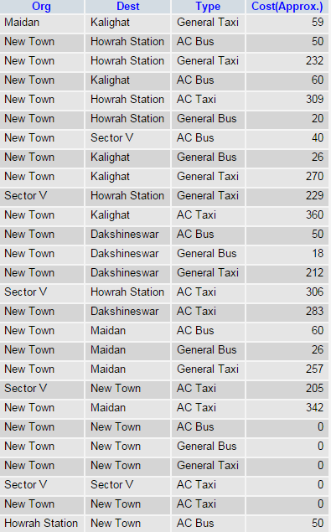

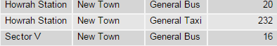

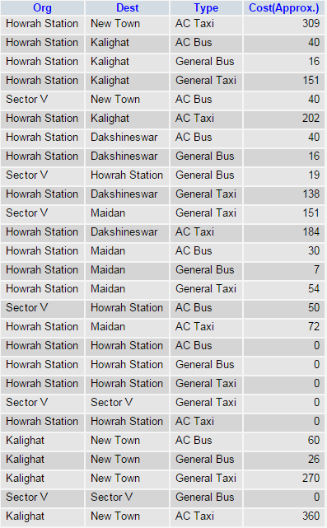

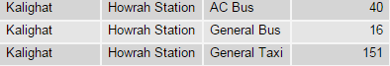

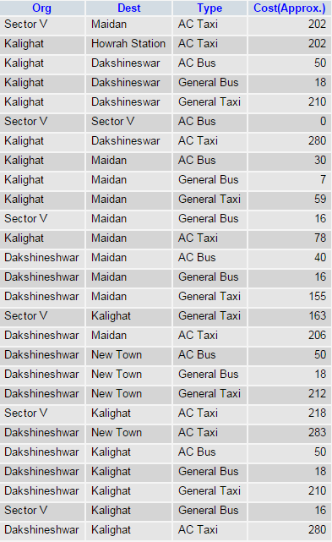

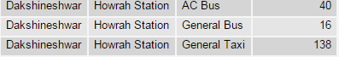

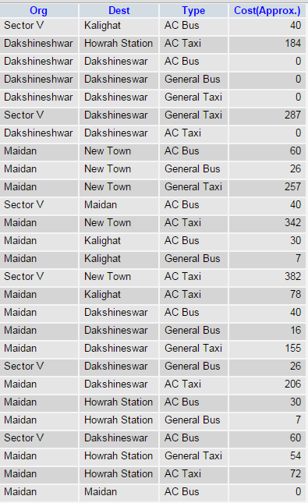

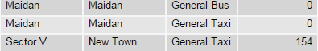

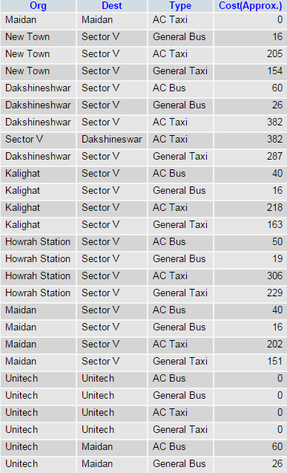

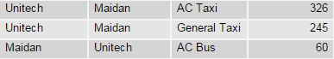

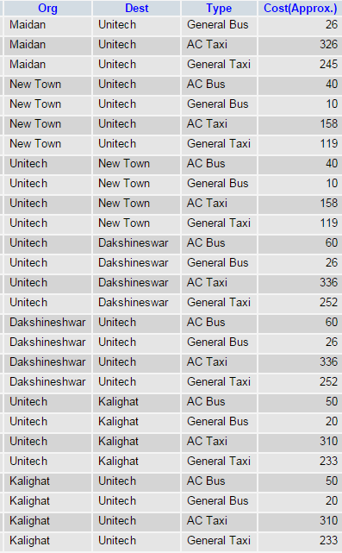

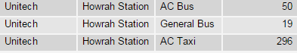

#### 

#### 4

#### CODING

1. HTML, CSS and JavaScript (for Interface Design)

1.1

<html>

<head>

<title>K-NAV</title>

<style type="text/css">

body{font-size:20pt;font-family:gabriola;color:blue;background-image:url("bc.png")}

h1{font-size:25pt;font-family:gabriola;font-style:bold;text-align:center;

background:skyblue;color:black;border:thick solid black;

box-shadow:5px 5px 2px green;text-shadow:2px 2px;}

p{text-incident:0.5in;margin-left:50px;margin-right:50px;}

h3{font-size:20pt;font-family:gabriola;font-style:bold;text-align:center;

color:black;}

h2{font-size:50pt;font-family:gabriola;font-style:bold;text-align:center;

color:black;text-shadow:2px 2px;}

a:link{color:black;font-size:20pt;font-family:gabriola;font-style:bold;}

a:hover{color:green;text-decoration:underline;font-size:20pt;

font-family:gabriola;font-style:bold;}

</style>

<link rel="icon" href="k.png" type="image/x-icon">

</head>

<body>

<h1><marquee>EXPERIENCE EASY TRAVELLING IN KOLKATA!!</marquee></h1>

<table align="center" border="10" bordercolor="green">

<tr>

<td width=407 height=100><iframe src="ex1.html" width=400 height=400></iframe></td>

<td align="center" width="200" height=100 border=5 bgcolor="skyblue">

<h3>Welcome</h3>

<h3>to</h3>

<h2>K-NAV</h2>

</td>

<td width=407 height=100><iframe src="ex11.html" width=400 height=400></iframe></td>

</tr>

</table><br/>

<table align="center" border=5 bordercolor="green">

<tr>

<td><a href="p2.html"><img src="bus.png" width=50 height=50></a></td>

<td bgcolor="skyblue" width=200 height=30 align="center">

<a href="fetch.html">Start Travelling</a></td>

<td><a href="p3.html"><img src="logo.png" width=50 height=50></td></a>

<td bgcolor="skyblue" width=200 height=30 align="center">

<a href="p3.html">Places of Attraction</a></td>

<td><a href="p5.html"><img src="msg.png" width=50 height=50></td></a>

<td bgcolor="skyblue" width=200 height=30 align="center">

<a href="p51.html">Contact Us</a></td>

<td><a href="p6.html"><img src="shr.png" width=50 height=50></td></a>

<td bgcolor="skyblue" width=200 height=30 align="center">

<a href="p6.html">Share</a></td>

</tr>

</table>

<form>

</form>

</body></html>

1.2

<html>

<head><title>PROJECT</title>

<style>

body

{

background-repeat: no-repeat;

background-position:6 6;

}

</style>

<script language="JavaScript">

var bgimages=new Array()

bgimages[0]="dak1.jpg"

bgimages[1]="eg1.jpg"

bgimages[2]="hb1.jpg"

bgimages[3]="kk1.jpg"

bgimages[4]="vc1.jpg"

bgimages[5]="im1.jpg"

bgimages[6]="bm11.jpg"

bgimages[7]="bp1.jpg"

//preload images

var pathToImg=new Array()

for (i=0;i<bgimages.length;i++){

pathToImg[i]=new Image()

pathToImg[i].src=bgimages[i]

}

var inc=-1

function bgSlide(){

if (inc<bgimages.length-1)

inc++

else

inc=0

document.body.background=pathToImg[inc].src

}

if (document.all||document.getElementById)

window.onload=new Function('setInterval("bgSlide()",3000)')

</script>

</head>

1.3

<html>

<head><title>PROJECT</title>

<style>

body

{

background-repeat: no-repeat;

background-position:6 6;

}

</style>

<script language="JavaScript">

var bgimages=new Array()

bgimages[0]="rb11.jpg"

bgimages[1]="sm1.jpg"

bgimages[2]="vs11.jpg"

bgimages[3]="mw11.jpg"

bgimages[4]="ep11.jpg"

bgimages[5]="mh1.jpg"

bgimages[6]="nz1.jpg"

bgimages[7]="ap1.jpg"

//preload images

var pathToImg=new Array()

for (i=0;i<bgimages.length;i++){

pathToImg[i]=new Image()

pathToImg[i].src=bgimages[i]

}

var inc=-1

function bgSlide(){

if (inc<bgimages.length-1)

inc++

else

inc=0

document.body.background=pathToImg[inc].src

}

if (document.all||document.getElementById)

window.onload=new Function('setInterval("bgSlide()",3000)')

</script>

</head>

1.4.1

<html>

<head>

<title>START TRAVELLING</title>

<style type="text/css">

body{font-size:20pt;font-family:gabriola;color:blue;background-image:url("bc.png")}

h1{font-size:25pt;font-family:gabriola;font-style:bold;text-align:center;background:skyblue;color:blue;border:thick solid black;}

p{text-incident:0.5in;margin-left:50px;margin-right:50px;}

h3{font-size:20pt;font-family:gabriola;font-style:bold;text-align:center;color:blue;}

h2{font-size:35pt;font-family:gabriola;font-style:bold;text-align:center;color:black;}

a:link{color:black;font-size:20pt;font-family:gabriola;font-style:bold;}

a:hover{color:green;text-decoration:underline;font-size:20pt;font-family:gabriola;font-style:bold;}

table{text-align:center;background:skyblue;color:black;font-size:20pt;border:thick dotted blue;font-family:gabriola;}

.design{text-align:center;color:black;font-size:20pt;font-family:gabriola;border:thin solid green;}

</style>

<link rel="icon" href="k.png" type="image/x-icon">

</head>

<body>

<form action=fetch.php method=post>

<center>

<h2>GET STARTED</h2>

<table cellspacing=10 cellpadding=10>

<tr>

<td>ORIGIN</td>

<td><input type=text name=n1></td>

</tr>

<tr>

<td>DESTINATION</td>

<td><input type=text name=n2></td>

</tr>

<tr>

<td>TYPE</td>

<td><select name=n3>

<optgroup label="BUS">

<option value="AC Bus">AC Bus</option>

<option value="General Bus">General Bus</option>

</optgroup>

<optgroup label="TAXI">

<option value="AC Taxi">AC Taxi</option>

<option value="General Taxi">General Taxi</option>

</optgroup>

</select>

</td>

</tr>

<tr>

<td colspan=2><input type=submit value=SHOW>

</form>

</td>

</tr>

</table>

<br/>

<table class="design" align="center">

<tr>

<td><a href="p6.html"><img src="mp.jpg" width=50 height=50></td></a>

<td bgcolor="skyblue" width=200 height=30 align="center"><a href="map1.html">Find your route!</a></td>

</tr>

</table>

<a href="pro.html"><h5 align="center">HOME</h5></a>

</body></html

1.4.2 (Visible only to programmers)

<html>

<body>

<form action=insert.php method=post>

<center>

<table border=2>

<tr>

<td>ORIGIN</td>

<td><input type=text name=n1></td>

</tr>

<tr>

<td>DESTINATION</td>

<td><input type=text name=n2></td>

</tr>

<tr>

<td>CHOOSE THE PARTICULAR TYPE OF TRANSPORT</td>

<td>

<input type=radio name=n3 value=AC Bus>AC Bus

<input type=radio name=n3 value=General Bus>General Bus

<input type=radio name=n3 value=AC Taxi>AC Taxi

<input type=radio name=n3 value=General Taxi>General Taxi

</td>

<tr>

<td>COST(Approx.)</td>

<td><input type=text name=n4></td>

</tr>

</table>

<br/><br/>

<center><input type=submit value=insert></center>

</center>

</form></body></html>

1.5

<html>

<head>

<title>PLACES OF ATTRACTION</title>

<style type="text/css">

body{font-size:20pt;font-family:broadway;color:black;background-image:url("bc.png")}

h1{font-size:40pt;font-family:gabriola;font-style:italic;text-align:center;background-image:url("blue.jpg");color:black;border:thick solid black;box-shadow:5px 5px 2px green;text-shadow:2px 2px 2px;}

p{text-incident:0.5in;margin-left:50px;margin-right:50px;}

h2{font-size:20pt;font-family:gabriola;font-style:bold;text-align:center;color:black;}

h3{font-size:20pt;font-family:gabriola;font-style:bold;text-align:center;color:black;}

a:link{color:black;font-size:15pt;font-family:gabriola;}

a:hover{color:green;text-decoration:underline;font-size:15pt;font-family:gabriola;}

td{text-align:justify;}

</style>

<link rel="icon" href="k.png" type="image/x-icon">

</head>

<body>

<h1>FEW PLACES OF ATTRACTION</h1>

<h3>Area: MAIDAN</h3>

<table align="left" border="3">

<tr>

<td align="left" rowspan=2><img src="vc.jpg" width=300 height=300 align="left"></td>

<td align="center" width="1500" bgcolor="skyblue"><h2>VICTORIA MEMORIAL</h2></td>

</tr>

<tr>

<td width="1500"><font face="Times New Roman">The Victoria Memorial (Victoria Memorial Hall) is a large marble building in Kolkata, West Bengal, India which was built between 1906 and 1921. It is dedicated to the memory of Queen Victoria (1819–1901) and is now a museum and tourist destination under the auspices of the Ministry of Culture.The Memorial lies on the Maidan by the bank of the Hooghly river, near Jawaharlal Nehru road. In January 1901, on the death of Queen Victoria, George Curzon, 1st Marquess Curzon of Kedleston and Viceroy of India, suggested the creation of a fitting memorial. He proposed the construction of a grand building with a museum and gardens. Curzon said,

<b><i>"Let us, therefore, have a building, stately, spacious, monumental and grand, to which every newcomer in Calcutta will turn, to which all the resident population, European and Native, will flock, where all classes will learn the lessons of history, and see revived before their eyes the marvels of the past."</i></b>

The Prince of Wales, later King George V, laid the foundation stone on 4 January 1906 and it was formally opened to the public in 1921.In 1912, before the Victoria Memorial was finished, King George V announced the transfer of the capital of India from Calcutta to New Delhi.Thus, the Victoria Memorial was built in what would be a provincial city rather than a capital.

<br/>

<b>(Timing: 10:00 a.m.-5:00 p.m. except Sunday,Monday Fees: Museum- Rs.10/person-Indian Rs.150/person-Foreigners;Garden- Rs.4/person)</b>

</td>

</tr>

</table>

<br/><hr/>

<h3>Other Attractions Nearby...</h3>

<hr/>

<table align="left" border="3">

<tr>

<td align="center" width="850" bgcolor="skyblue"><h2>EDEN GARDENS</h2></td>

<td align="left" rowspan=2><img src="eg.jpg" width=300 height=200 align="right"></td>

</tr>

<tr>

<td width="1500"><font face="Times New Roman">Eden Gardens is a cricket ground in Kolkata, India. It is the home of the Bengal cricket team and the Indian Premier League's Kolkata Knight Riders, as well as being a venue for Test, One Day International and Twenty20 International matches. The largest cricket stadium in India by seating capacity, it is widely acknowledged to be one of the most iconic cricket stadiums in the world. Eden Gardens has been called "cricket's answer to the Colosseum".Established in 1864, Eden Gardens currently holds 66,349 people following renovations for the Cricket World Cup 2011; a capacity down from an estimated 100,000 before the upgrade. Before the 1987 World Cup, the capacity was said to be approximately 120,000; however, no official figures have been recorded. But six time reached hundred thousands plus attendance.

Before 1984 both cricket and derby football matches were played in Eden Garden. The stadium is in the B. B. D. Bagh area of the city, near the State Secretariat and Calcutta High Court.

</td>

</tr>

</table>

<table align="left" border="3">

<tr>

<td align="left" rowspan=2><img src="mh1.jpg" width=300 height=200 align="left"></td>

<td width="1500" bgcolor="skyblue"><h2>MISSIONARIES OF CHARITY(MOTHER'S HOUSE)</h2></td>

</tr>

<tr>

<td align="left" width="1500"><font face="Times New Roman">Missionaries of Charity is a Roman Catholic Latin Rite religious congregation established in 1950 by Mother Teresa. It consists of over 4,501 religious sisters and is active in 133 countries. Members of the order designate their affiliation using the order's initials, "M.C." A member of the Congregation must hear to the vows of chastity, poverty, obedience, and the fourth vow, to give "wholehearted free service to the poorest of the poor."

<br/><br/><br/><br/></td>

</tr>

</table>

<table align="left" border="3">

<tr>

<td align="center" width="1500" bgcolor="skyblue"><h2>INDIAN MUSEUM</h2></td>

<td align="left" rowspan=2><img src="im.jpg" width=300 height=200 align="right"></td>

</tr>

<tr>

<td width="1500"><font face="Times New Roman">The Indian Museum is the largest and oldest museum in India and has rare collections of antiques, armour and ornaments, fossils, skeletons, mummies, and Mughal paintings. It was founded by the Asiatic Society of Bengal in Kolkata, India, in 1814. The founder curator was Dr Nathaniel Wallich, a Danish botanist.

It has six sections comprising thirty five galleries of cultural and scientific artifacts namely Art, Archaeology, Anthropology, Geology, Zoology and Economic Botany. This multipurpose Institution with multidisciplinary activities is being included as an Institute of national importance in the seventh schedule of the Constitution of India.It is one of oldest museums in the world. This is an autonomous organization under Ministry of Culture, Government of India. The present Director of the Indian Museum is Dr. B. Venugopal.

<br/><b>(Timing: March to November-10:00 a.m.-5:00 p.m. December to February-10:00 a.m.-4:30 p.m. Fees: Rs.10/person-Indians Rs.150/person-Foreigners)</b>

</td>

</tr>

</table>

<table align="left" border="3">

<tr>

<td align="left" rowspan=2><img src="sm1.jpg" width=300 height=200 align="left"></td>

<td align="center" width="1500" bgcolor="skyblue"><h2>SHAHEED MINAR</h2></td>

</tr>

<tr>

<td width="1500"><font face="Times New Roman">The Shaheed Minar (Martyrs' Monument), formerly known as the Ochterlony Monument), is a monument in Kolkata that was erected in 1828 in memory of Major-general Sir David Ochterlony, commander of the British East India Company, to commemorate both his successful defense of Delhi against the Marathas in 1804 and the victory of the East India Company’s armed forces over the Gurkhas in the Anglo-Nepalese War. The monument was constructed in his memory. It was designed by J.P. Parker and paid for from public funds.

In August 1969, it was rededicated to the memory of the martyrs of the Indian freedom movement and hence renamed the "Shahid Minar," which means "martyrs monument" in both Bengali and Hindi, by the then United Front Government in memory of the martyrs of the Indian independence movement. The present government has decided to illuminate the tower during evenings and allow visitors to the top. The last persons who went up there were former governor Gopal Krishna Gandhi and his family.

</td>

</tr>

</table>

<table align="left" border="3">

<tr>

<td align="center" width="1500" bgcolor="skyblue"><h2>RAJ BHAVAN</h2></td>

<td align="left" rowspan=2><img src="rb1.jpg" width=300 height=200 align="right"></td>

</tr>

<tr>

<td width="1500"><font face="Times New Roman">Raj Bhavan is the official residence of the Governor of West Bengal, located in the state' capital city Kolkata. Built in 1803, it was known as the Government House in the pre-independence days.

Later after the transfer of power from the East India Company to the British Crown in 1858 it became the official residence of the Viceroy of India, shifting here from the Belvedere Estate. With the shifting of capital to Delhi in 1911 it became the official residence of Lieutenant Governor of Bengal. Since independence in 1947 it serves as the official residence of the Governor of West Bengal and came to be known as the Raj Bhavan, a name it shares with the official residences of other states' governors.

<br/></td>

</tr>

</table>

<table align="left" border="3">

<tr>

<td align="left" rowspan=2><img src="bp1.jpg" width=300 height=200 align="left"></td>

<td align="center" width="1500" bgcolor="skyblue"><h2>BIRLA PLANETARIUM</h2></td>

</tr>

<tr>

<td width="1500"><font face="Times New Roman">The Birla Planetarium in Kolkata, West Bengal, India, is a single-storeyed circular structure designed in the typical Indian style, whose architecture is loosely styled on the Buddhist Stupa at Sanchi. Situated at Chowringhee Road adjacent to the Victoria Memorial, St. Paul's Cathedral, and the Maidan in South Kolkata, it is the largest planetarium in Asia and the second largest planetarium in the world.<br/><br/><br/><br/>

<br/>

<b>(Timing: 12:00 p.m.-6:30 p.m. Fees: Rs.40/person)</b>

</tr>

</table>

<table align="left" border="3">

<tr>

<td align="center" width="1500" bgcolor="skyblue"><h2>ALIPORE ZOOLOGICAL GARDENS</h2>

</td>

<td align="left" rowspan=2><img src="az1.jpg" width=300 height=200 align="right"></td>

</tr>

<tr>

<td width="1500"><font face="Times New Roman">The Alipore Zoological Gardens (also informally called the Alipore Zoo, Calcutta Zoo or Kolkata Zoo) is India's oldest formally stated zoological park (as opposed to royal and British menageries) and a big tourist attraction in Kolkata, West Bengal. It has been open as a zoo since 1876, and covers 18.81 ha (46.5 acres). It is probably best known as the home of the now expired Aldabra giant tortoise Adwaita, which was reputed to have been over 250 years old when it died in 2006. It is also home to one of the few captive breeding projects involving the Manipur brow-antlered deer.

The zoo had its roots in a private menagerie established by Governor General of India, Richard Wellesley, established around 1800 in his summer home at Barrackpore near Kolkata, as part of the Indian Natural History Project.

<br/>

<b>(Timing: 9:30 a.m.-5:00 p.m. Fees: Rs.20/person)</b>

</td>

</tr>

</table>

<table align="right">

<tr>

<td width=40 height=40><a href="pro.html"><img src="bb.png" width=40 height=40 align="left"></a></td>

<td width=40 height=40><a href="p4.html"><img src="fb.png" width=52 height=52 align="right"></a></td>

</tr>

</table>

</body>

</html>

1.6

<html>

<head>

<title>PLACES OF ATTRACTION</title>

<style type="text/css">

body{font-size:20pt;font-family:broadway;color:black;background-image:url("bc.png")}

h1{font-size:40pt;font-family:gabriola;font-style:bold;text-align:center;background:skyblue;color:black;border:thick solid black;text-shadow:2px 2px 2px;}

p{text-incident:0.5in;margin-left:50px;margin-right:50px;}

h2{font-size:20pt;font-family:gabriola;font-style:bold;text-align:center;color:black;}

a:link{color:black;font-size:15pt;font-family:consolas;}

a:hover{color:red;text-decoration:underline;font-size:15pt;font-family:gabriola;}

td{text-align:justify;}

</style>

<link rel="icon" href="k.png" type="image/x-icon">

</head>

<body>

<table align="center" border="3">

<tr>

<td><img src="bridge.jpg" height=100 width=100></td>

<td align="center" width=225><font face="Gabriola" color="black" size=7>THE BRIDGES</td>

</tr>

</table>

<br/>

<table align="center" border="3">

<tr>

<td><img src="hb.jpg" height=200 width=550></td>

<td><img src="vs1.jpg" height=200 width=550></td>

</tr>

<tr>

<td align="center" width=300 bgcolor=skyblue><h2>HOWRAH BRIDGE</h2></td>

<td align="center" width=300 bgcolor=skyblue><h2>VIVEKANANDA SETU</h2></td>

</tr>

<tr>

<td width=300><font face="Times New Roman">Howrah Bridge is a cantilever bridge with a suspended span over the Hooghly River in West Bengal, India. Commissioned in 1943, the bridge was originally named the New Howrah Bridge, because it replaced a pontoon bridge at the same location linking the two cities of Howrah and Kolkata. On 14 June 1965 it was renamed Rabindra Setu, after the great Bengali poet Rabindranath Tagore, who was the first Indian and Asian Nobel laureate. It is still popularly known as the Howrah Bridge.

The bridge is one of two on the Hooghly River and is a famous symbol of Kolkata and West Bengal. The other bridges are the Vidyasagar Setu (popularly called the Second Hooghly Bridge), the Vivekananda Setu, and the newly built Nivedita Setu. It weathers the storms of the Bay of Bengal region, carrying a daily traffic of approximately 100,000 vehicles and possibly more than 150,000 pedestrians,easily making it the busiest cantilever bridge in the world. The third-longest cantilever bridge at the time of its construction, the Howrah Bridge is the sixth-longest bridge of its type in the world.

</td>

<td width=300><font face="Times New Roman">Vivekananda Setu (also called Willingdon Bridge and Bally Bridge) is a bridge over the Hooghly River in West Bengal, India. It links the city of Howrah, at Bally, to its twin city of Kolkata, at Dakshineswar. Completed in December 1932, it is a multispan steel bridge and was built to provide road and rail link between the Calcutta Port and its hinterland. It is 2,887 feet (880 m) long.

The construction of bridge was done by famous Kutchi-Mistri contractor and Industrialist Rai Bahadur Jagmal Raja Chauhan. His nameplate can still be seen on each girder of the bridge. The construction of bridge started in year 1926 and was completed in year 1932.

<br/><br/><br/><br/><br/><br/>

</td>

</tr>

</table>

<table align="right">

<tr>

<td width=40 height=40><a href="p3.html"><img src="bb.png" width=40 height=40 align="left"></a></td>

<td width=40 height=40><a href="p31.html"><img src="fb.png" width=52 height=52 align="right"></a></td>

</tr>

</table>

</body></html>

1.7

<html>

<head>

<title>PLACES OF ATTRACTION</title>

<style type="text/css">

body{font-size:20pt;font-family:broadway;color:black;background-image:url("bc.png")}

h1{font-size:40pt;font-family:gabriola;font-style:bold;text-align:center;background:skyblue;color:blue;border:thick solid black;text-shadow:2px 2px 2px;}

p{text-incident:0.5in;margin-left:50px;margin-right:50px;}

h2{font-size:20pt;font-family:gabriola;font-style:bold;text-align:center;color:black;}

h3{font-size:20pt;font-family:gabriola;font-style:bold;text-align:center;color:black;}

a:link{color:black;font-size:15pt;font-family:consolas;}

a:hover{color:green;text-decoration:underline;font-size:15pt;font-family:gabriola;}

td{text-align:justify;}

</style>

<link rel="icon" href="k.png" type="image/x-icon">

</head>

<body background="bc.png">

<table align="center" border="3">

<tr>

<td><img src="mon.png" height=100 width=100></td>

<td align="center" width=300><font face="Gabriola" color="black" size=7>FAMOUS TEMPLES</td>

</tr>

</table>

</body>

</html>

<br/>

<table align="left" border="3">

<tr>

<td align="left" rowspan=2><img src="dak.jpg" width=300 height=400 align="left"></td>

<td align="center" width="400" bgcolor="skyblue"><h2>DAKSHINESWAR KALI TEMPLE</h2></td>

<td align="left" rowspan=2><img src="kk.jpg" width=300 height=400 align="left"></td>

<td align="center" width="400" bgcolor="skyblue"><h2>KALIGHAT KALI TEMPLE</h2></td>

</tr>

<tr>

<td width="400"><font face="Times New Roman">Dakshineswar Kali Temple is a Hindu temple located in Dakshineswar near Kolkata. Situated on the eastern bank of the Hooghly River, the presiding deity of the temple is Bhavatarini, an aspect of Kali, meaning, 'She who liberates Her devotees from the ocean of existence. The temple was built by Rani Rashmoni, a philanthropist and a devotee of Kali in 1855. The temple is famous for its association with Ramakrishna, a mystic of 19th Century Bengal. The temple compound, apart from the nine-spired main temple, contains a large courtyard surrounding the temple, with rooms along the boundary walls. There are twelve shrines dedicated to Shiva

—Kali's companion—along the riverfront, a temple to Radha-Krishna, a bathing ghat on the river, a shrine dedicated to Rani Rashmoni. 'Nahavat-Khana', the chamber in the northwestern corner just beyond the last of the Shiva temples, is where Ramakrishna spent a considerable part of his life.

<td width="400"><font face="Times New Roman">Kalighat Kali Temple is a Hindu temple in West Bengal, India dedicated to the Hindu goddess Kali. It is one of the 51 Shakti Peethas.

Kalighat was a Ghat (landing stage) sacred to Kali on the old course of the Hooghly river in the city of Calcutta. The name Calcutta is said to have been derived from the word Kalighat. The river over a period of time has moved away from the temple. The temple is now on the banks of a small canal called Adi Ganga which connects to the Hoogly. The Adi Ganga was the original course of the river Hoogly (the Ganges). Hence the name Adi (original) Ganga.The temple is visited by pilgrims from all over India irrespective of sectarian differences.

<br/><br/><br/><br/></td>

</tr>

</table>

<hr/>

<h3>Other temples near Dakkhineshwar</h3>

<hr/>

<table align="left" border="3">

<tr>

<td align="center" width="1500" bgcolor="skyblue"><h2>BELUR MATH</h2></td>

<td align="left" rowspan=2><img src="bm1.jpg" width=300 height=200 align="right"></td>

</tr>

<tr>

<td width="1500"><font face="Times New Roman">Belur Math or Belur Mutt is the headquarters of the Ramakrishna Math and Mission, founded by Swami Vivekananda, a chief disciple of Ramakrishna Paramahamsa. It is located on the west bank of Hooghly River, Belur, West Bengal, India and is one of the significant institutions in Calcutta.This temple is the heart of the Ramakrishna Movement. The temple is notable for its architecture that fuses Hindu, Christian and Islamic motifs as a symbol of unity of all religions.

<br/>

<b>(Timing: April to September-6.00 a.m.-11.30 a.m./4.00-7.00 p.m. October to March-6.30 a.m.-11.30 a.m../3.30 p.m.-6.00 p.m.)</b>

<br/>

<br/>

</td>

</tr>

</table>

<table align="left" border="3">

<tr>

<td align="left" rowspan=2><img src="ap1.jpg" width=300 height=200 align="left"></td>

<td align="center" width="1500" bgcolor="skyblue"><h2>ADYAPITH TEMPLE</h2></td>

</tr>

<tr>

<td width="1500"><font face="Times New Roman">Dakshineswar Ramkrishna Sangha Adyapith, founded in 1921 by Sri Annada Thakur, is an organization dedicated to the service of humanity and the worship of the Divine Mother.

On a large compound just outside Calcutta in the historic village of Dakshineswar, the Sangha operates orphanages, schools, homes for the elderly, ashrams, and services for the poor, including food, clothing, and medical care. At the center of all this activity is a loving devotion to the Divine Mother, in the tradition of the great Bengali saint, Sri Ramakrishna, in a uniquely beautiful white marble temple.

<br/><br/><br/>

</td>

</tr>

</table>

<table align="right">

<tr>

<td width=40 height=40><a href="p4.html"><img src="bb.png" width=40 height=40 align="left"></a></td>

<td width=40 height=40><a href="p41.html"><img src="fb.png" width=52 height=52 align="right"></a></td>

</tr>

</table>

</body>

</html>

1.8

<html>

<head>

<title>PLACES OF ATTRACTION</title>

<style type="text/css">

body{font-size:20pt;font-family:broadway;color:black;background-image:url("bc.png")}

h1{font-size:40pt;font-family:gabriola;font-style:italic;text-align:center;background-image:url("blue.jpg");color:black;border:thick solid black;box-shadow:5px 5px 2px green;}

p{text-incident:0.5in;margin-left:50px;margin-right:50px;}

h2{font-size:20pt;font-family:gabriola;font-style:bold;text-align:center;color:black;text-shadow:2px 2px 2px;}

h3{font-size:20pt;font-family:gabriola;font-style:bold;text-align:center;color:black;}

a:link{color:black;font-family:gabriola;}

a:hover{color:green;text-decoration:underline;font-family:gabriola;}

td{text-align:justify;}

</style>

<link rel="icon" href="k.png" type="image/x-icon">

</head>

<body>

<h3>Area: NEW TOWN</h3>

<hr/>

<table align="left" border="3">

<tr>

<td align="center" width="850" bgcolor="skyblue"><h2>MOTHER'S WAX MUSEUM</h2></td>

<td align="left" rowspan=2><img src="mw1.jpg" width=300 height=200 align="right"></td>

</tr>

<tr>

<td align="left" width="1500"><font face="Times New Roman">The Mother’s Wax Museum is set up in the satellite township of Rajarhat New Town. The museum features life-like wax figures of icons and celebrities.It is India's first wax museum, and has been made on the lines of the world-famous Madame Tussauds.

The Mother’s Wax Museum pays homage to towering talents of the country. The wax figures have been created by Susanta Ray, a veteran wax sculptor. The museum occupies the sixth floor of the New Town Financial Hub, opposite the sprawling Eco-Tourism Park.

<br/>

<b>(Timings:12:00 a.m.-7:30 p.m. except Monday Fees: Rs.150/person)</b>

<br/></td>

</tr>

</table>

<table align="left" border="3">

<tr>

<td align="left" rowspan=2><img src="ep1.jpg" width=300 height=200 align="left"></td>

<td align="center" width="1500" bgcolor="skyblue"><h2>ECO TOURISM PARK</h2></td>

</tr>

<tr>

<td align="left" width="1500"><font face="Times New Roman">New Town Eco Park is an urban park in Rajarhat, Kolkata. The park is situated on a 480 acres (190 ha) plot and is surrounded by a 104 acres (42 ha) waterbody with an island in the middle.

The park has been divided into three broad parts: ecological zones like wetlands, grasslands, and urban forest, theme gardens and open spaces, and urban recreational spaces.

<br/>

<b>(Timing: Sunday-12:00 p.m.-8:30 p.m. Tuesday-Saturday-2:00 p.m-8:30 p.m. Fees: Rs.20/person)</b>

<br/><br/>

</td>

</tr>

</table>

<table align="left" border="3">

<tr>

<td align="center" width="1500" bgcolor="skyblue"><h2>RABINDRA TIRTHA</h2></td>

<td align="left" rowspan=2><img src="rt1.jpg" width=300 height=200 align="right"></td>

</tr>

<tr>

<td align="left" width="1500"><font face="Times New Roman">Rabindra Tirtha Complex (Tagore Pilgrimage) is a cultural center in Narkel Bagan, New Town, Kolkata. It is dedicated to Rabindranath Tagore.It is a project developed by the HIDCO It houses an exhibition of Tagore’s paintings, archives, a research centre, an auditorium and dormitories for students opting to conduct their research on Tagore.

<br/>

<b>(Timing: Weekdays- 2:00 p.m.-8:00 p.m. Sunday- 12:00 p.m.-8:00 p.m. Fees: Rs.10/person)</b>

<br/><br/><br/>

</td>

</tr>

</table>

<table align="left" border="3">

<tr>

<td align="left" rowspan=2><img src="nz.jpg" width=300 height=200 align="left"></td>

<td align="center" width="1500" bgcolor="skyblue"><h2>NAZRUL TIRTHA</h2></td>

</tr>

<tr>

<td align="left" width="1500"><font face="Times New Roman">Nazrul Tirtha (Nazrul Pilgrimage) is a cultural and educational center dedicated to the rebel poet Kazi Nazrul Islam. The center is situated at Action Area 1, New Town (few meters away from Rabindra Tirtha). It was inaugurated on 24 May 2014 to mark the occasion of the 115th birth anniversary of the poet.

<br/><br/><br/><br/>

</td>

</tr>

</table>

<table align="right">

<tr>

<td width=40 height=40><a href="p31.html"><img src="bb.png" width=40 height=40 align="left"></a></td>

<a href="pro.html"><h5 align="center">HOME</h5></a>

</tr>

</table>

</body>

</html>

1.9

<html>

<head>

<title>CONTACT US</title>

<style type="text/css">

body{font-size:20pt;font-family:gabriola;color:black;background-image:url("bc.png");text-align:center;}

h2{font-size:20pt;font-family:gabriola;font-style:bold;text-align:center;color:black;}

fieldset{width:500px;border:5px ridge green; font-family:gabriola;padding:10px;background-color:skyblue;}

legend{font-family:gabriola,"Times New Roman",serif;font-weight:bold;font-size:20px;align:center;}

a:link{color:black;font-size:20pt;font-family:gabriola;font-style:bold;}

a:hover{color:green;text-decoration:underline;font-size:20pt;font-family:gabriola;font-style:bold;}

</style>

<link rel="icon" href="k.png" type="image/x-icon">

</head>

<body>

<center>

<fieldset>

<legend>CONTACT US</legend>

<h2>GIVE US YOUR FEEDBACK AT</h2>

<h2>kolkatanav@gmail.com</h2>

<a href="pro.html"><h5 align="center">HOME</h5></a>

</body>

</html>

1.10

<html>

<head>

<title>SHARE</title>

<style type="text/css">

body{font-size:20pt;font-family:gabriola;color:black;background-image:url("bc.png")}

h1{font-size:25pt;font-family:gabriola;font-style:bold;text-align:center;background:skyblue;color:blue;border:thick solid black;box-shadow:5px 5px 2px green;text-shadow:2px 2px;}

p{text-incident:0.5in;margin-left:50px;margin-right:50px;}

h3{font-size:20pt;font-family:gabriola;font-style:bold;text-align:center;color:blue;text-shadow:2px 2px;}

h2{font-size:30pt;font-family:gabriola;font-style:bold;text-align:center;color:black;text-shadow:2px 2px;}

a:link{color:black;font-size:20pt;font-family:gabriola;font-style:bold;}

a:hover{color:green;text-decoration:underline;font-size:20pt;font-family:gabriola;font-style:bold;}

</style>

<link rel="icon" href="k.png" type="image/x-icon">

</head>

<body>

<table align="center" border="3">

<tr>

<td><img src="shr.png" height=100 width=100></td>

<td align="center" width=400><h2>SHARE ABOUT US<h2/></td>

</tr>

</table>

<br/><br/>

<table align="center" border="3" cellspacing=50 bordercolor="green" bgcolor="skyblue">

<tr>

<td><a href="https://www.facebook.com/knavig"><img src="fb.jpg" height=100 width=100></a></td>

<td><a href="https://plus.google.com/b/100323816236634326109/100323816236634326109/about"><img src="go.png" height=100 width=100></a></td>

</tr>

</table>

<a href="pro.html"><h5 align="center">HOME</h5></a></body></html>

2. PHP (For database access and cost calculation):

2.1

<?php

$or=$_POST['n1'];

$dest=$_POST['n2'];

$type=$_POST['n3'];

$cost=$_POST['n4'];

$dc=mysql_connect("localhost","root","");

if($dc>0)

mysql_select_db("clsdb");

$q="insert into trsp values('$or','$dest','$type','$cost')";

$s=mysql_query($q);

if($s>0)

echo"<h1>Inserted Successfully";

mysql_close();

?>

2.2

<html>

<head>

<title>START TRAVELLING</title>

<style type="text/css">

body{font-size:20pt;text-align:center;font-family:gabriola;color:black;background-image:url("bc.png")}

h1{font-size:25pt;font-family:gabriola;font-style:bold;text-align:center;background:skyblue;color:blue;border:thick solid black;}

p{text-incident:0.5in;margin-left:50px;margin-right:50px;}

h2{font-size:20pt;font-family:gabriola;font-style:bold;text-align:center;color:blue;}

a:link{color:blue;font-size:20pt;font-family:gabriola;font-style:bold;}

a:hover{color:green;text-decoration:underline;font-size:20pt;font-family:gabriola;font-style:bold;}

table{text-align:center;background:skyblue;color:blue;font-size:20pt;border:thick dotted blue;font-family:gabriola;}

</style>

<link rel="icon" href="k.png" type="image/x-icon">

</head>

<body>

<?php

$or=$_POST['n1'];

$dest=$_POST['n2'];

$type=$_POST['n3'];

$dc=mysql_connect("localhost","root","");

if($dc>0)

mysql_select_db("clsdb");

$q="select *from trsp where Org = '$or'and Dest = '$dest'and Type = '$type'";

$s=mysql_query($q);

if($r=mysql_fetch_array($s))

{

echo "<h2>ORIGIN:</h2>".$r[0];

echo "<h2>DESTINATION:</h2>".$r[1];

echo "<h2>TYPE OF TRANSPORT:</h2>".$r[2];

echo "<h2>COST(Approx.):</h2>".$r[3];

}

else echo "<h1>DATA IS NOT AVAILABLE!!!";

mysql_close();

?>

<a href="fetch.html"><h5 align="center">Go Back</h5></a>

</body>

</html

3. GOOGLE MAP (Application Programming Interface)

<!DOCTYPE html>

<html>

<head>

<meta name="viewport" content="initial-scale=1.0, user-scalable=no">

<meta charset="utf-8">

<title>Directions service</title>

<style>

html, body, #map-canvas {

height: 100%;

margin: 0px;

padding: 0px

}

#panel {

position: absolute;

top: 5px;

left: 50%;

margin-left: -180px;

z-index: 5;

background-color: #fff;

padding: 5px;

border: 1px solid #999;

}

</style>

<script src="https://maps.googleapis.com/maps/api/js?v=3.exp&signed_in=true"></script>

<script>

var directionsDisplay;

var directionsService = new google.maps.DirectionsService();

var map;

function initialize() {

directionsDisplay = new google.maps.DirectionsRenderer();

var park_circus = new google.maps.LatLng(22.54320,88.36610);

var mapOptions = {

zoom:12,

center: park_circus

};

map = new google.maps.Map(document.getElementById('map-canvas'), mapOptions);

directionsDisplay.setMap(map);

}

function calcRoute() {

var start = document.getElementById('start').value;

var end = document.getElementById('end').value;

var request = {

origin:start,

destination:end,

travelMode: google.maps.TravelMode.TRANSIT

};

directionsService.route(request, function(response, status) {

if (status == google.maps.DirectionsStatus.OK) {

directionsDisplay.setDirections(response);

}

});

}

google.maps.event.addDomListener(window, 'load', initialize);

</script>

</head>

<body>

<div id="panel">

<b>Start: </b>

<select id="start" onchange="calcRoute();">

<option value=22.54302,88.36887>Maidan</option>

<option value=22.60551,88.46970>New Town</option>

<option value=22.65664,88.36311>Dakkhineshwar</option>

<option value=22.51695,88.34587>Kalighat</option>

<option value=22.59577,88.26364>Howrah</option>

<option value=22.57353,88.43312>Sector V</option>

<option value=22.57977,88.46219>Unitech, Rajarhat</option>

<optgroup label="Attractions">

<option value=22.56286,88.34923>Shadeed Minar</option>

<option value=22.56726,88.34752>Raj Bhawan</option>

<option value=22.56465,88.34329>Eden Gardens</option>

<option value=22.55263,88.36337>Mother House</option>

<option value=22.54481,88.34256>Victoria Memorial</option>

<option value=22.53576,88.33214>Alipore Zoo</option>

<option value=22.55789,88.35113>Indian Museum</option>

<option value=22.55551,88.32986>Vidyasagar Setu</option>

<option value=22.65496,88.35770>Dakkhineshwar Temple</option>

<option value=22.62638,88.35550>Belur Math</option>

<option value=22.66066,88.36348>Adyapith Temple</option>

<option value=22.58500,88.34716>Howrah Bridge</option>

<option value=22.59942,88.47208>Mother Wax Museum</option>

<option value=22.60215,88.46579>Eco Park</option>

<option value=22.58013,88.47051>Rabindra Tirtha</option>

<option value=22.58206,88.44841>Nazrul Tirtha</option>

<option value=22.52024,88.342099>Kalighat Temple</option>

</optgroup>

</select>

<b>End: </b>

<select id="end" onchange="calcRoute();">

<option value=22.54302,88.36887>Maidan</option>

<option value=22.60551,88.46970>New Town</option>

<option value=22.65664,88.36311>Dakkhineshwar</option>

<option value=22.51695,88.34587>Kalighat</option>

<option value=22.59577,88.26364>Howrah</option>

<option value=22.57353,88.43312>Sector V</option>

<option value=22.57977,88.46219>Unitech, Rajarhat</option>

<optgroup label="Attractions">

<option value=22.56286,88.34923>Shadeed Minar</option>

<option value=22.56726,88.34752>Raj Bhawan</option>

<option value=22.56465,88.34329>Eden Gardens</option>

<option value=22.55263,88.36337>Mother House</option>

<option value=22.54481,88.34256>Victoria Memorial</option>

<option value=22.53576,88.33214>Alipore Zoo</option>

<option value=22.55789,88.35113>Indian Museum</option>

<option value=22.55551,88.32986>Vidyasagar Setu</option>

<option value=22.65496,88.35770>Dakkhineshwar Temple</option>

<option value=22.62638,88.35550>Belur Math</option>

<option value=22.66066,88.36348>Adyapith Temple</option>

<option value=22.58500,88.34716>Howrah Bridge</option>

<option value=22.59942,88.47208>Mother Wax Museum</option>

<option value=22.60215,88.46579>Eco Park</option>

<option value=22.58013,88.47051>Rabindra Tirtha</option>

<option value=22.58206,88.44841>Nazrul Tirtha</option>

<option value=22.52024,88.342099>Kalighat Temple</option>

</select>

</div>

<div id="map-canvas"></div>

</body>

</html>

Coding Description:

* **DirectionsService** is an object that communicates with the Google Maps API Directions Service which receives direction requests and returns computed results.
* These directions results are handled ourselves or the use of DirectionsRenderer object is done to render these results.
* Directions are specied by origins and destinations as **LatLng** values.
* The Directions service can return multi-part directions using a series of waypoints. Directions are displayed as a polyline drawing the route on a map, or additionally as a series of textual description within a <div> element.
* **origin** specifies the start location from which to calculate directions. This value is specified as a LatLng value. **destination** specifies the end location to which to calculate directions. This value is specified as a LatLng value.
* **travelMode** specifies what mode of transport to use when calculating directions.
* **transitOptions** specifies values that apply only to requests where travelMode is **google.maps.TravelMode.TRANSIT.**
* **google.maps.TravelMode.TRANSIT** requests directions via public transit routes.
* The DirectionsStatus value **OK** indicates the response contains a valid DirectionsResult.
* **map = new google.maps.Map(document.getElementById('map-canvas'), mapOptions) :** is used create the map canvas on which the map is displayed.

#### 5

#### INTERFACE DESIGN

5.1 SCREENSHOTS – For User

1. HOME PAGE - SELECT “Start Travelling”

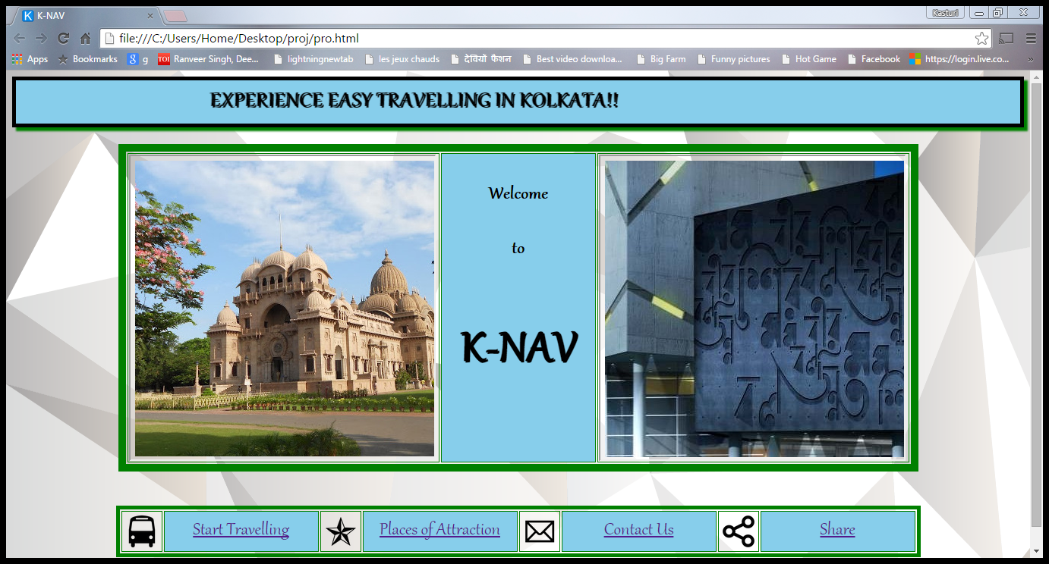

2. ENTER ORIGIN & DESTINATION

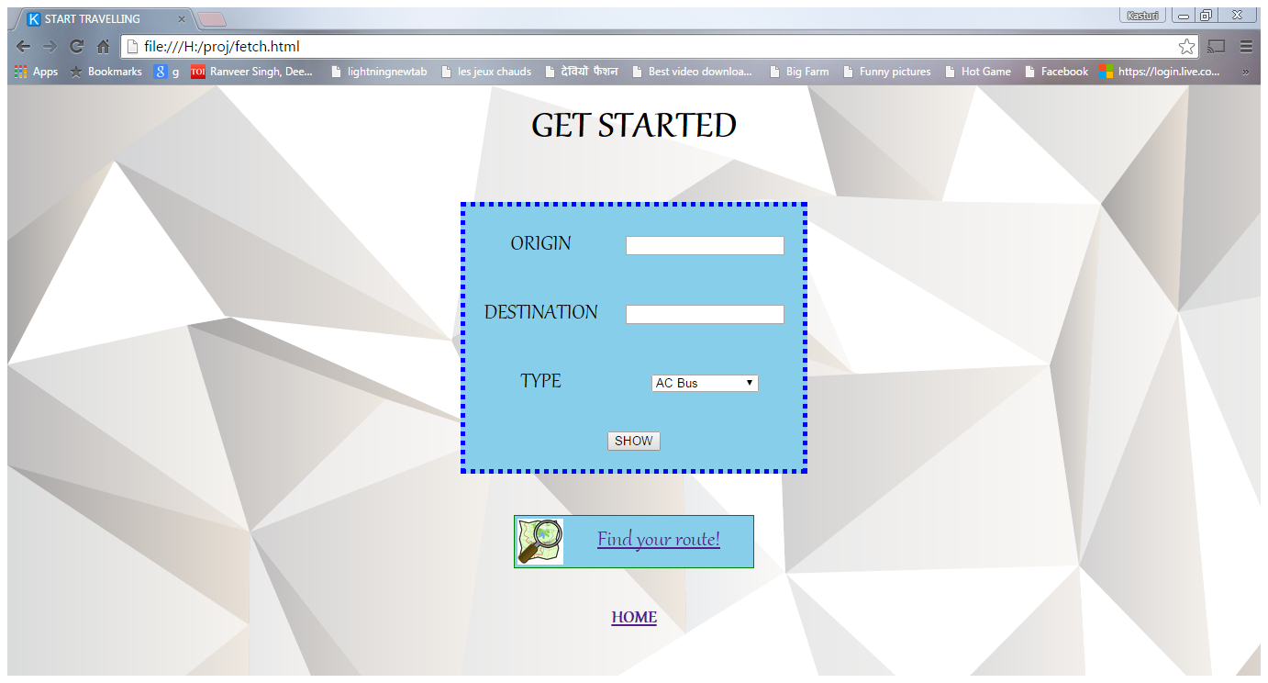

3. ENTER TRANSPORT TYPE

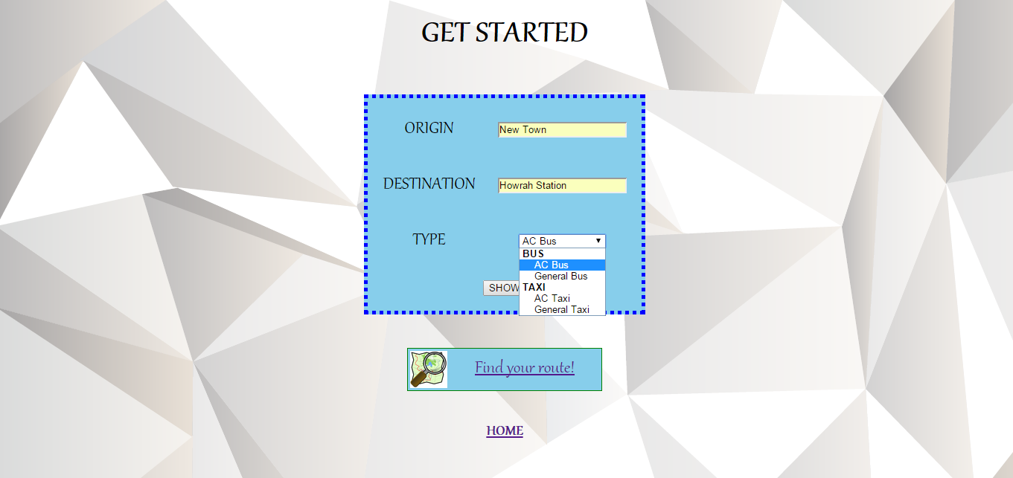

4. SELECT “SHOW”

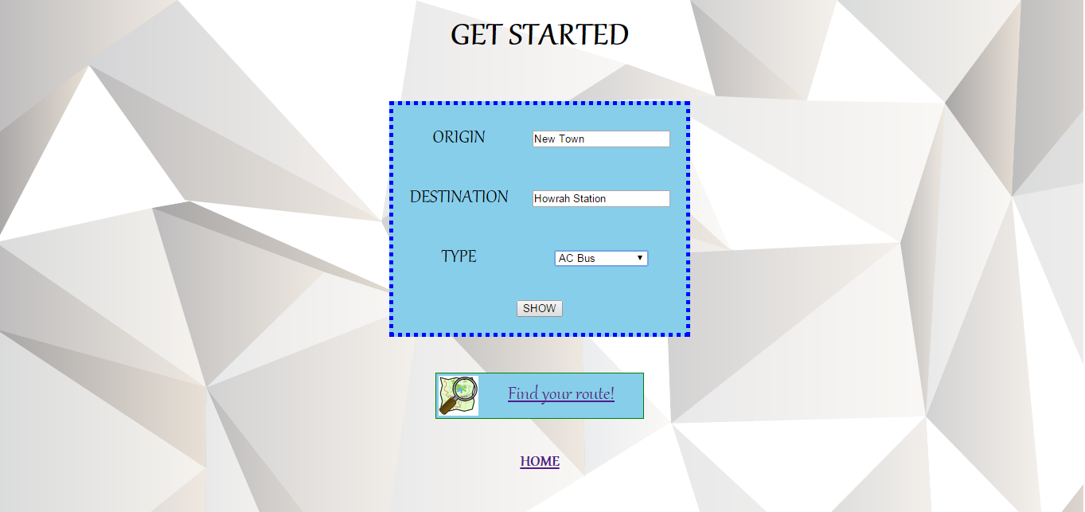

5. GET COST DETAILS

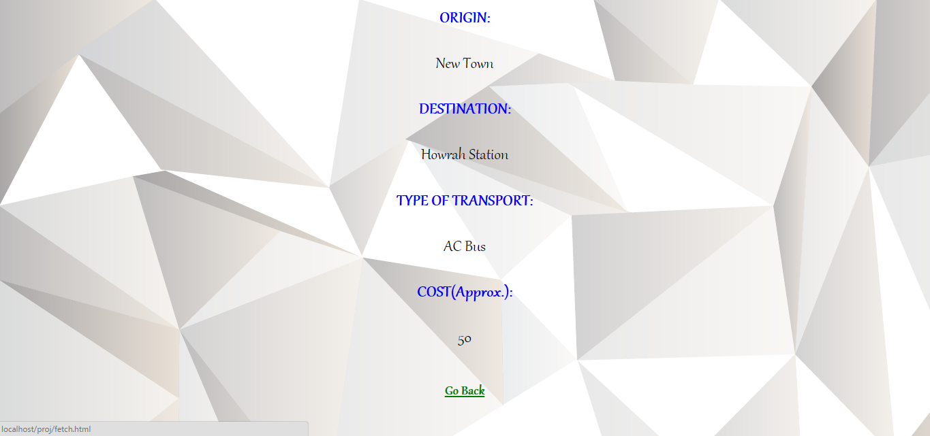

6. SELECT “Find your route!”

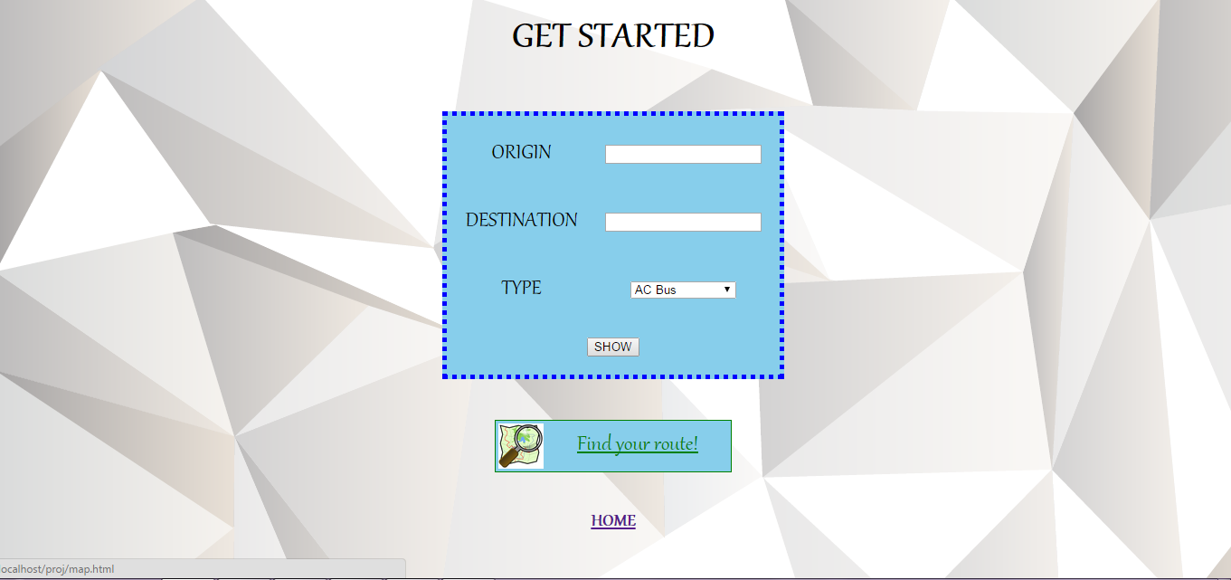

7. CHOOSE “Start” and “End”

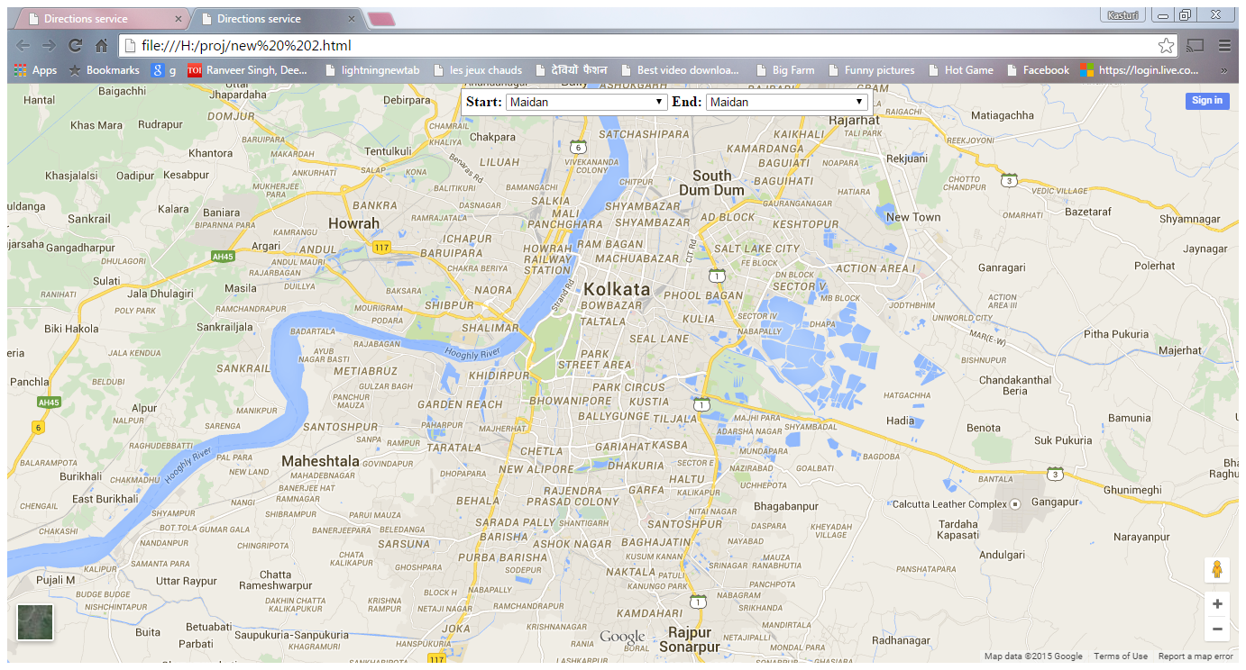

8. VIEW SHORTEST DISTANCE VIA MAP

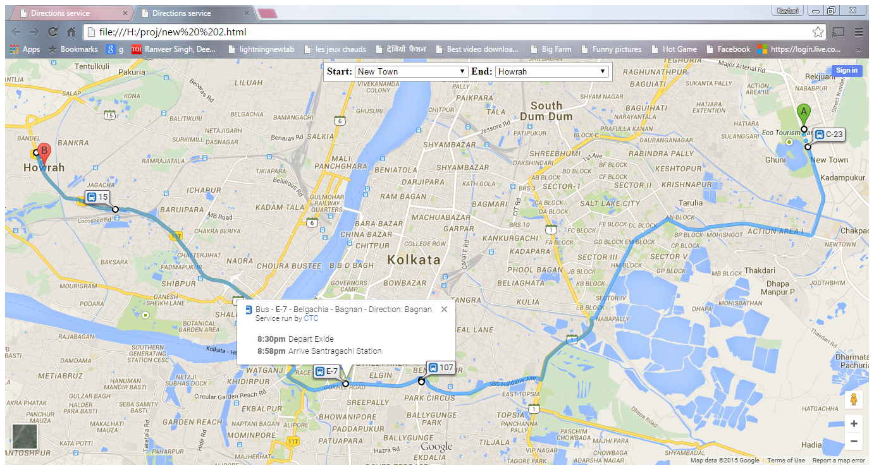

9. SELECT “Places of Attraction”

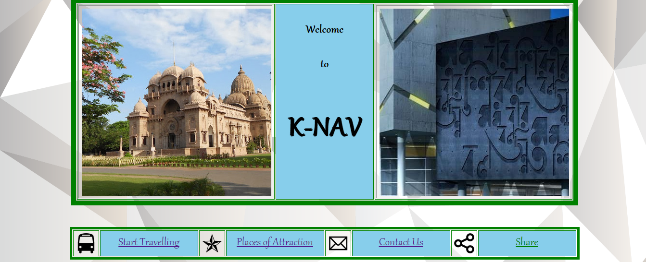

10. VIEW INFORMATION ON “Places of Attraction”

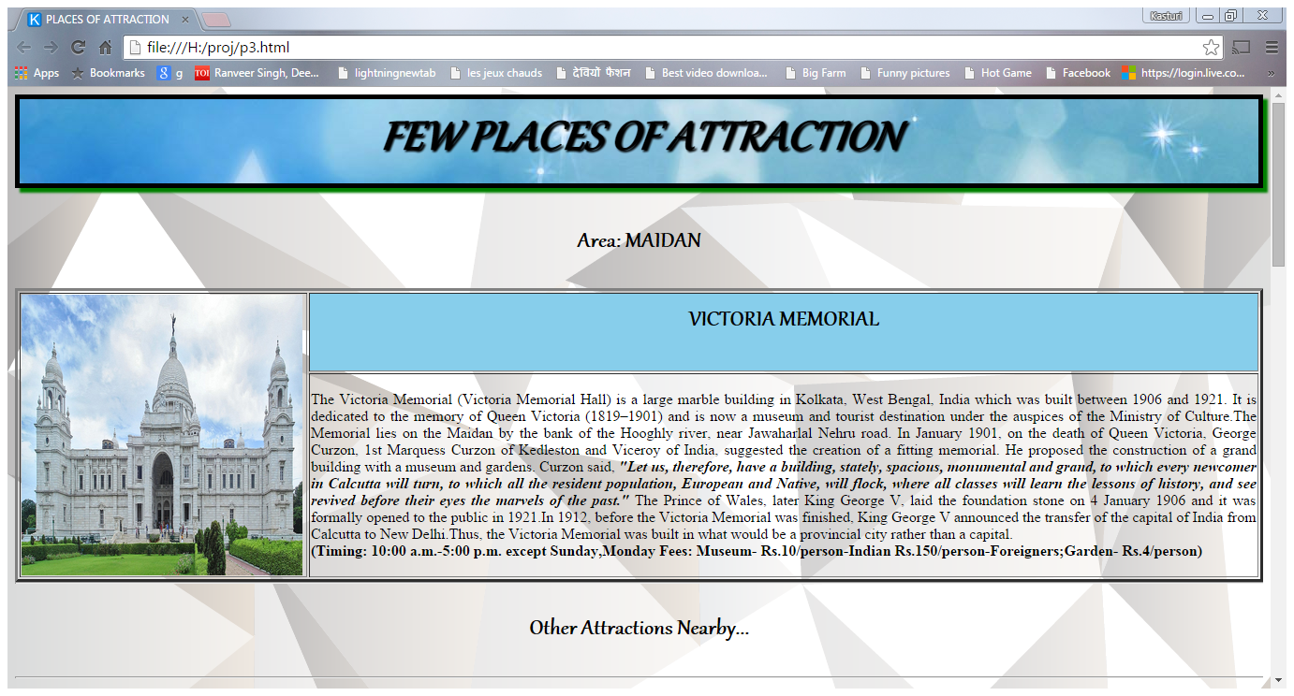

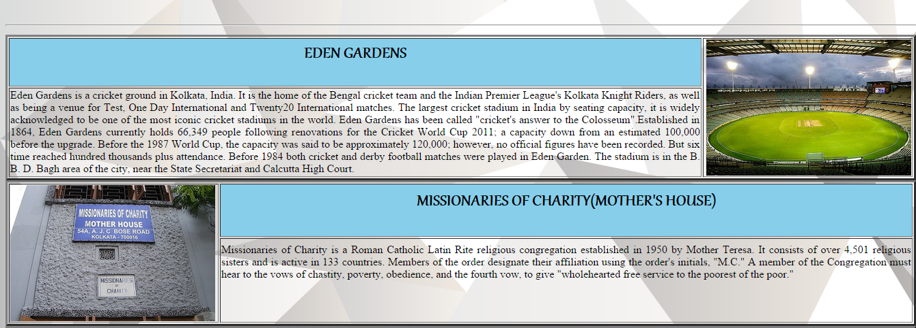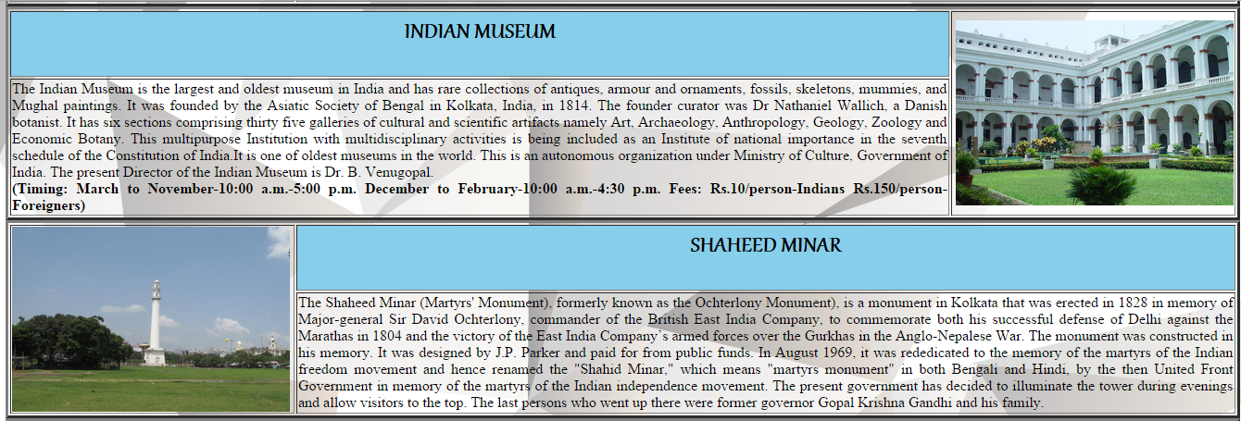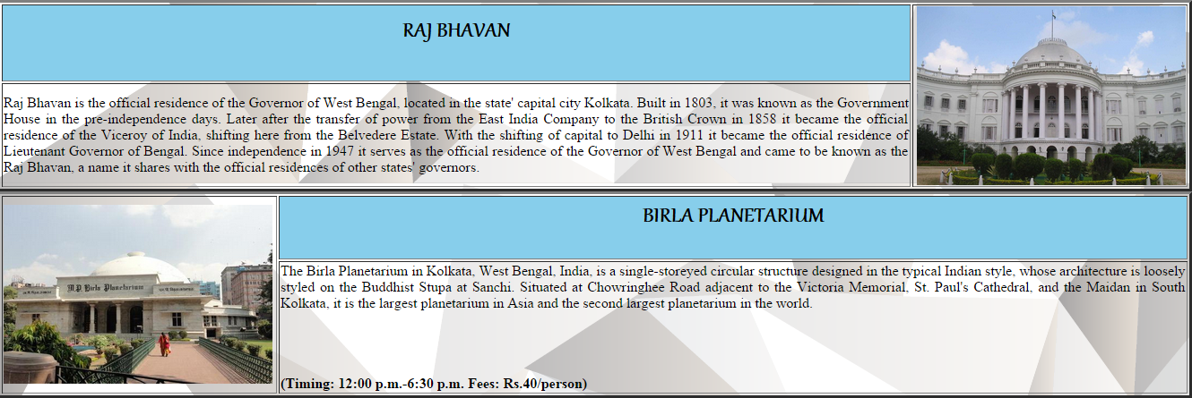

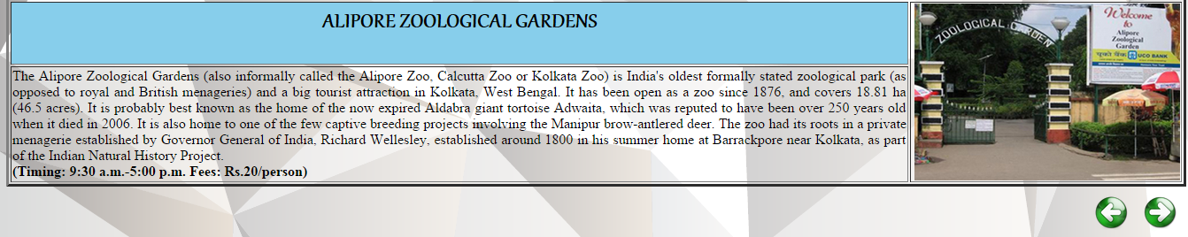

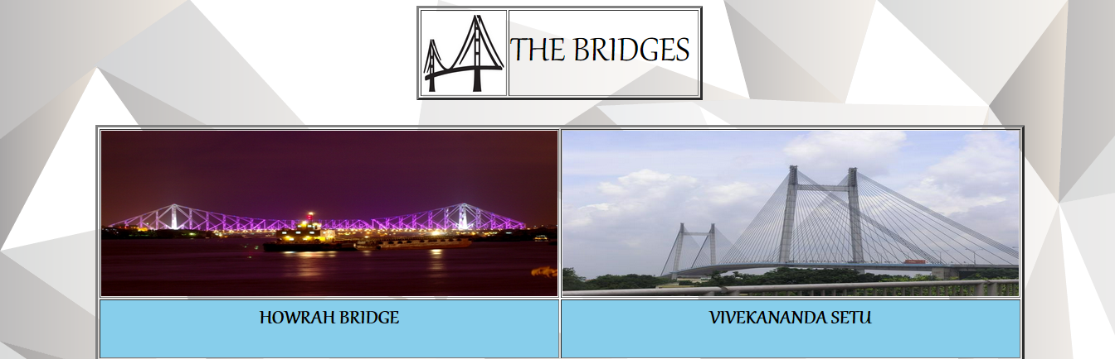

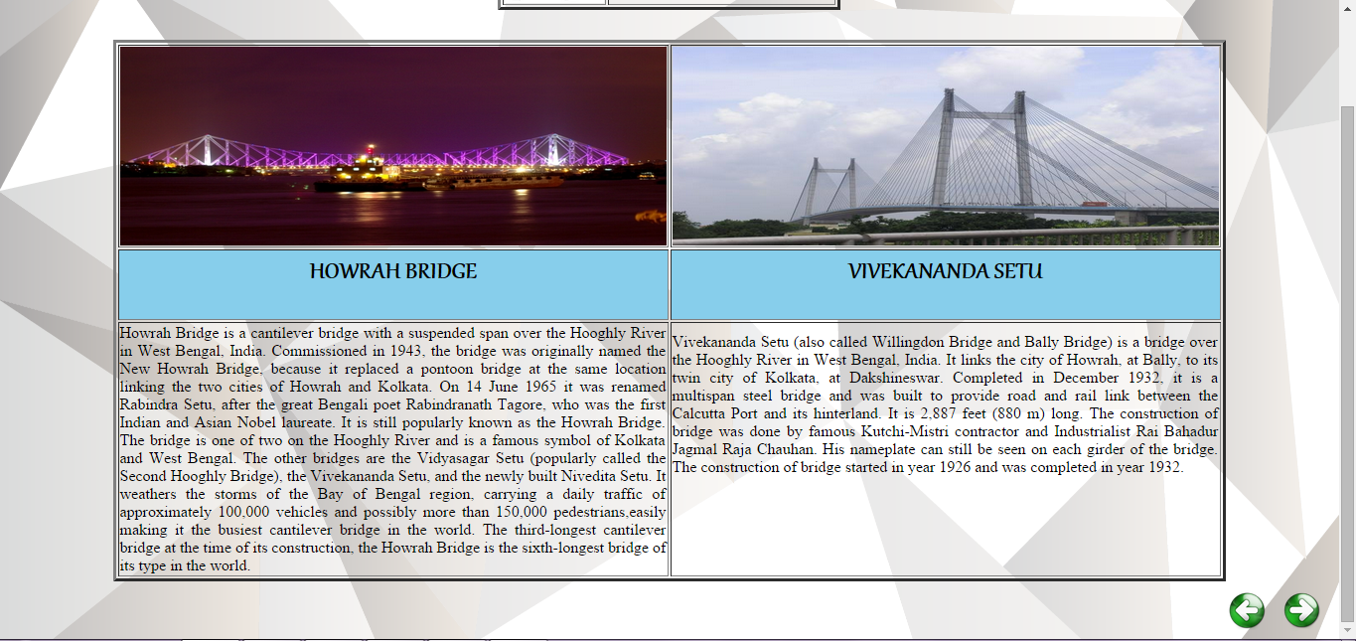

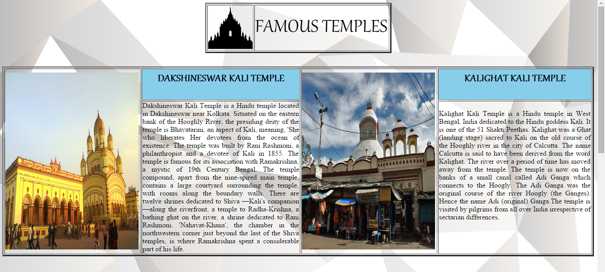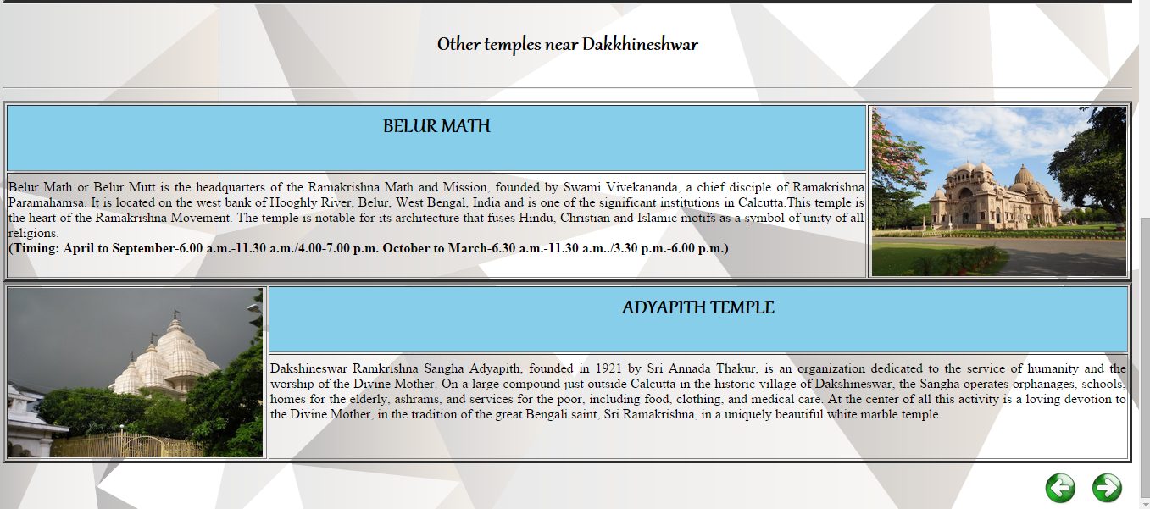

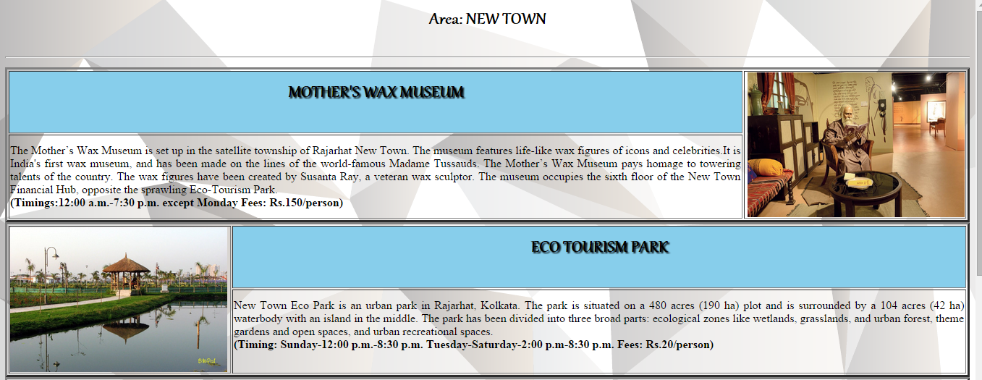

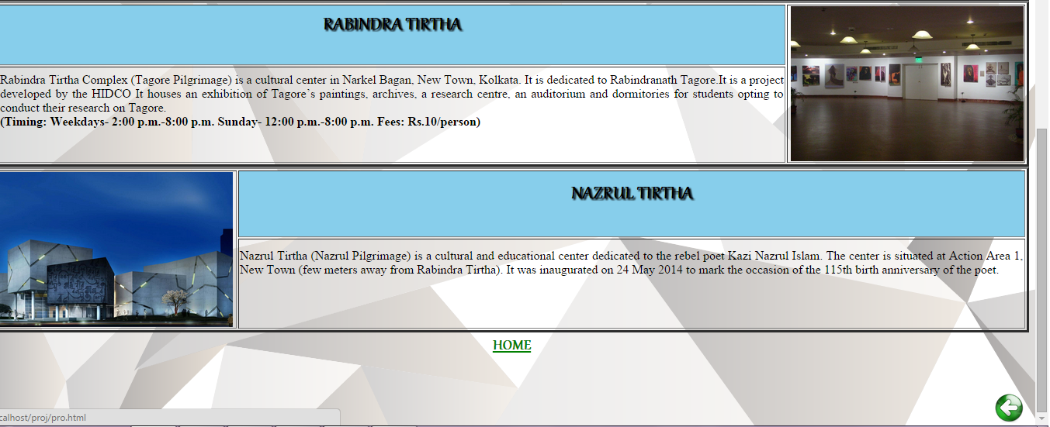

11. SELECT “Contact Us”



12. VIEW CONTACT DETAILS

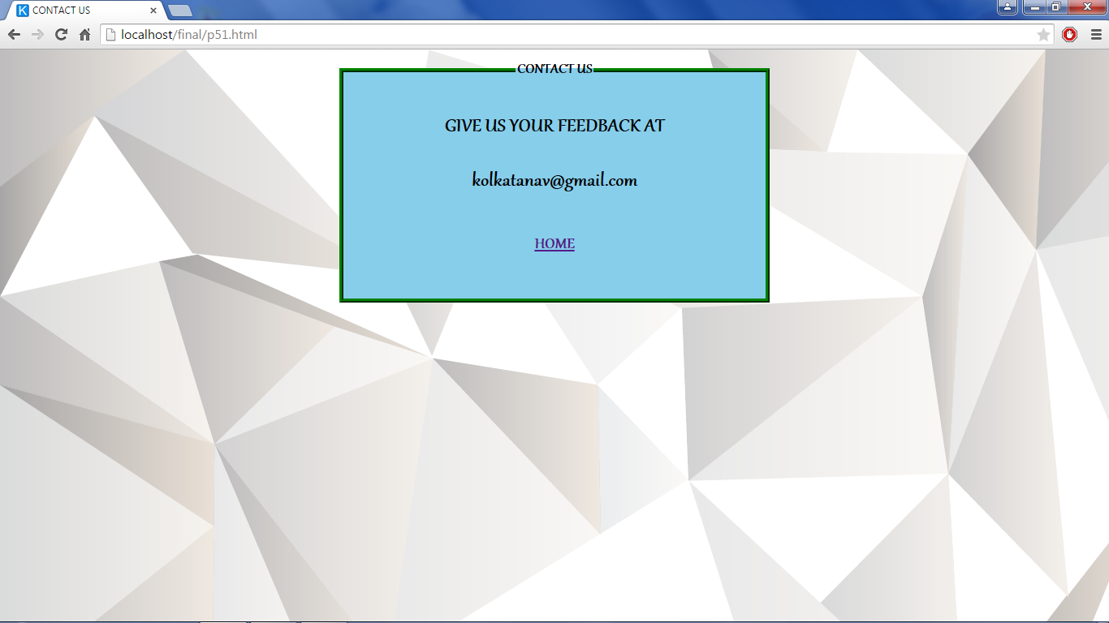

13. SELECT “Share”



14. SELECT SHARING OPTION

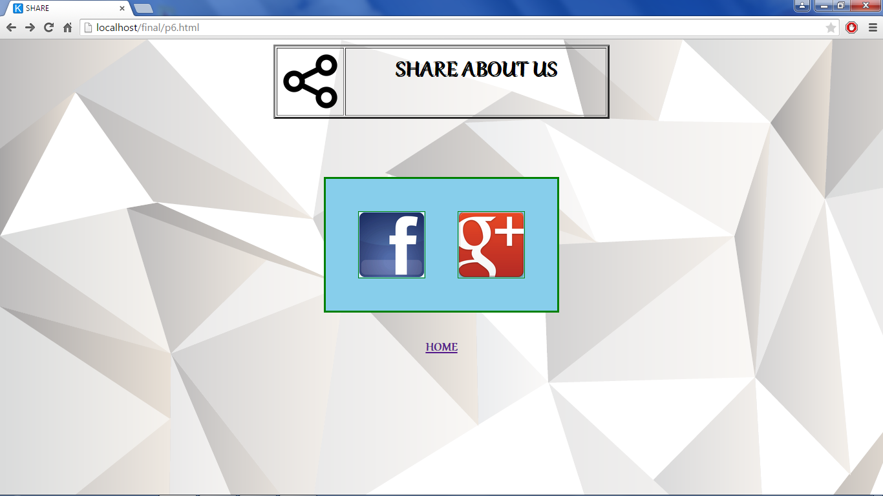

15. SHARE VIA FACEBOOK

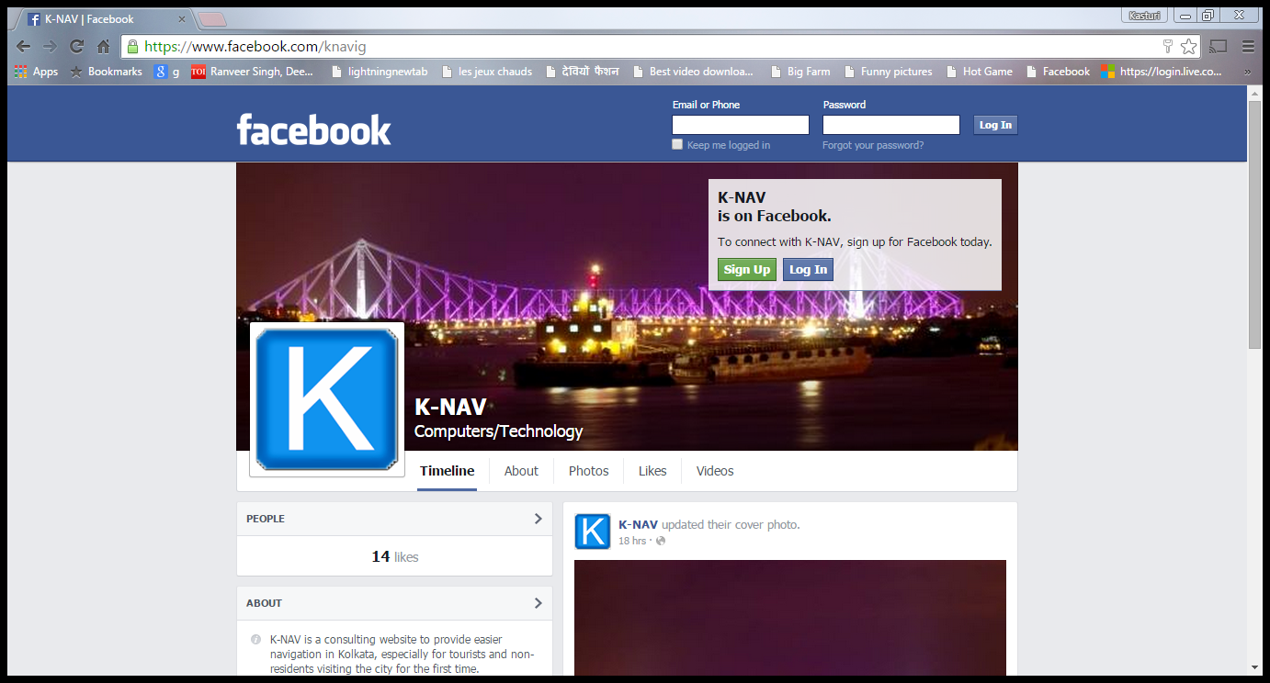

16. SHARE VIA GOOGLE+

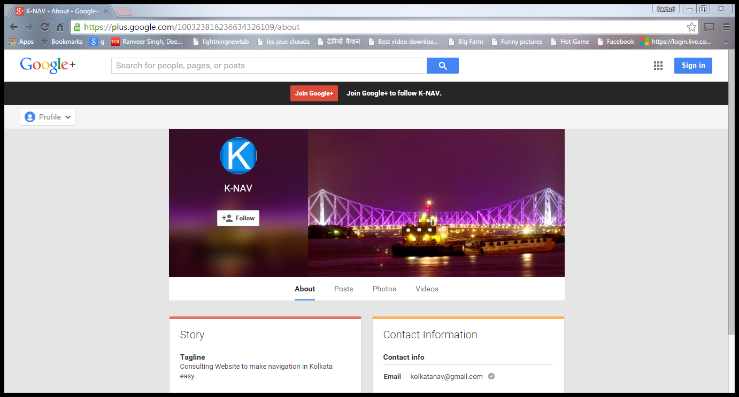

For programmer:

1. Download the XAMPP Software according to the programmer RAM size.

2. Open the XAMPP Control Panel.

3. In the modules click on "Start" button for Apache and MySql.

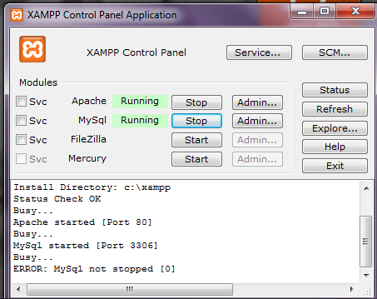

4. Store the whole websites pages within the htdocs folder which is present within C-Drive's Xampp folder.

5. Start the Google Chrome browser by typing http://localhost/.

6. It will open the Xampp software home page.

7. Click on "PhpMyAdmin" which is present within the "Tools".

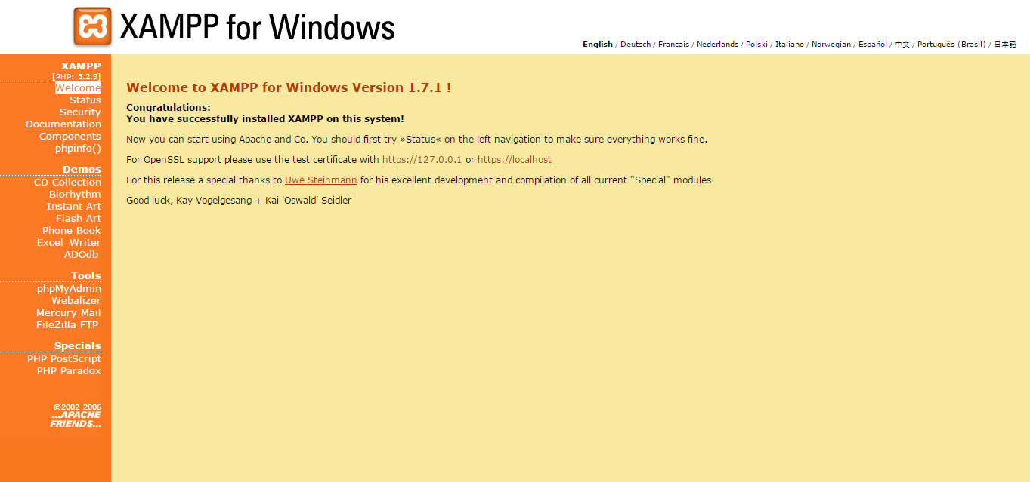

8. Type the database name as "clsdb" in create new database.

9. Click on "create".

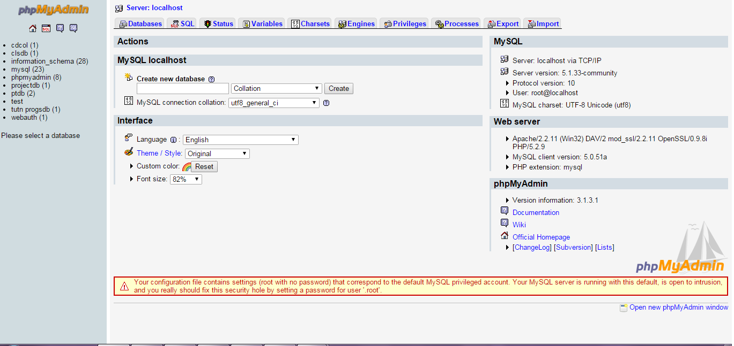

10. Type the table name as "trsp" in table name.

11. Type no of fields (4).

12. Click on "GO".

13. Type the field, type, length according to the below table.

|  |  |  |
| --- | --- | --- |
| Field | Type | Length |
| Org | VARCHAR | 15 |
| Dest | VARCHAR | 15 |
| Type | VARCHAR | 15 |
| Cost | INT | 15 |

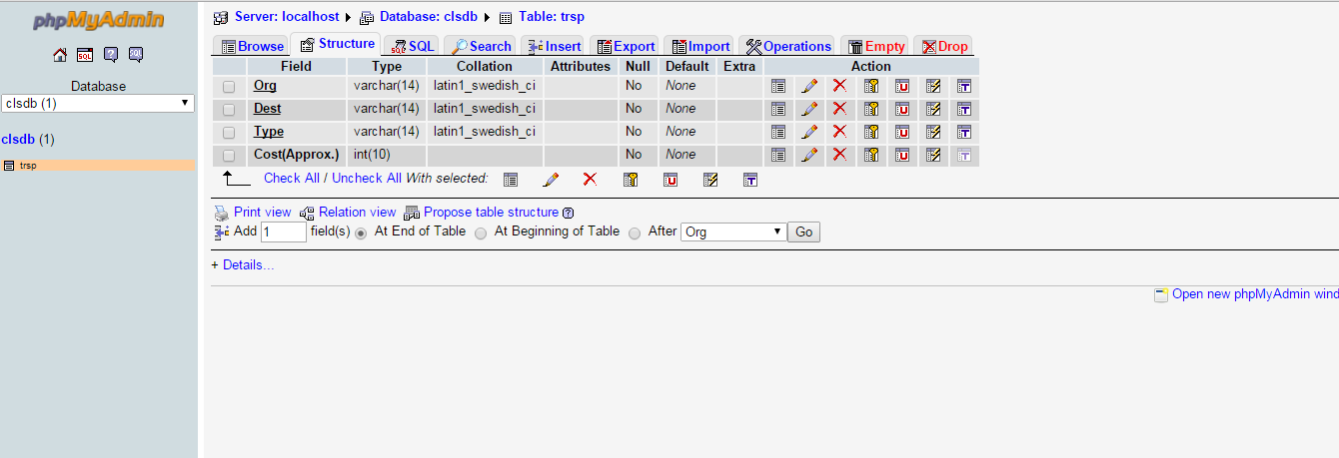

14. Click on "SAVE".

15. Select Org, Dest, Type and click on Primary key.

16. Run “Insert .html” file using Google Chrome.

“insert.html”

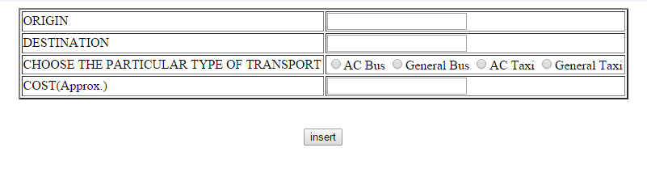

17. Insert values of database in “insert.html”

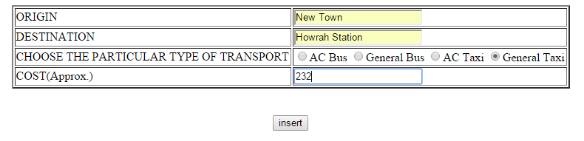

18. It will show “insert.php” page by showing “INSERTED SUCCESSFULLY”.

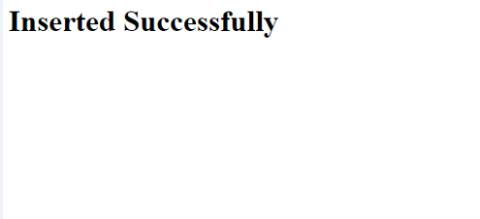

19. Again in the table page click on “Browse” and it will show the data whatever the programmer inserted into that table.

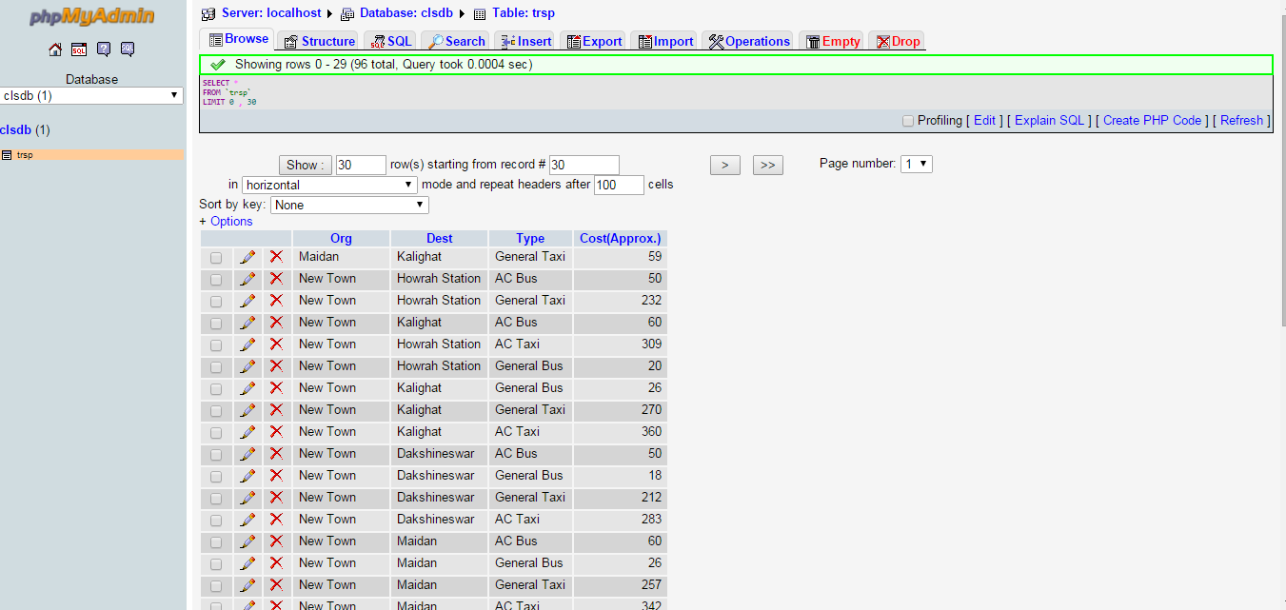

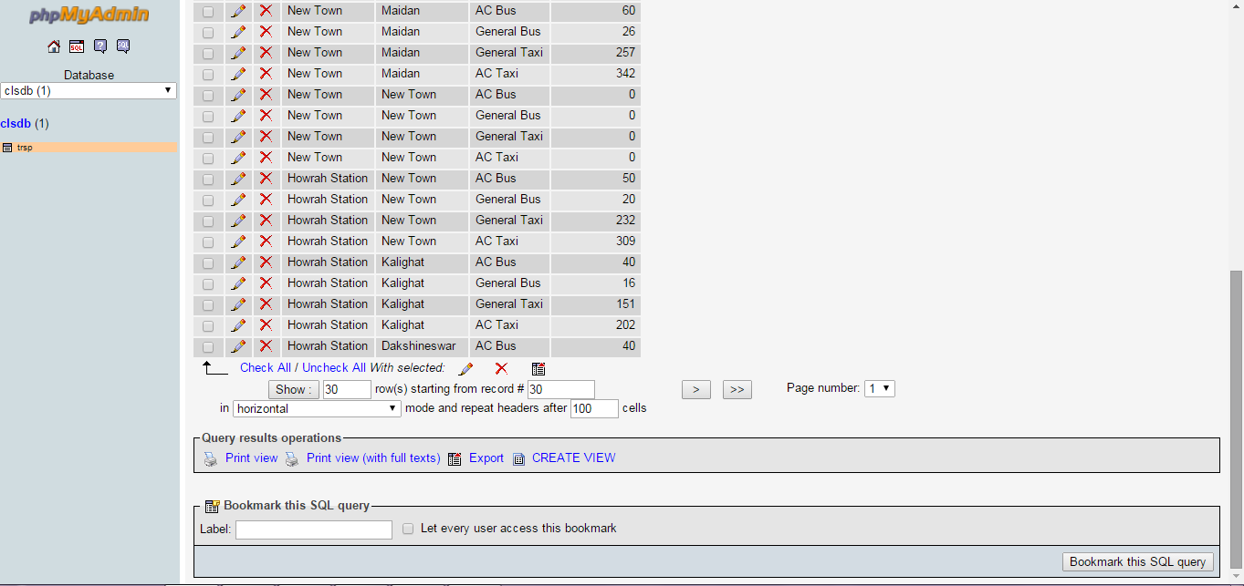

20. Now programmer can easily delete, modify, update, edit the data using the corresponding options that are show within the table.

21. Now open a new tab by writing [http://localhost/proj. (“proj](http://localhost/proj.%20(“proj) is the folder name”). It will show all the documents that stores in the folder.

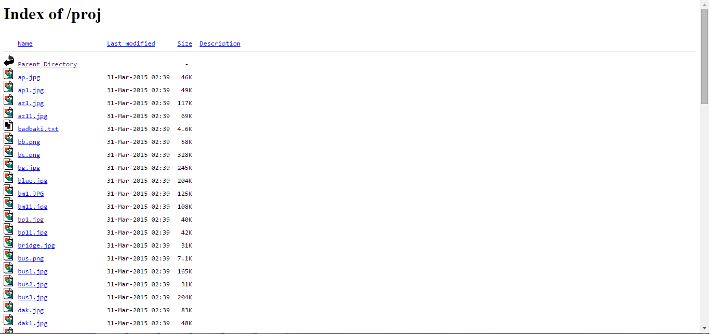

22. Start from “pro.html” and operations in the user steps are carried out.

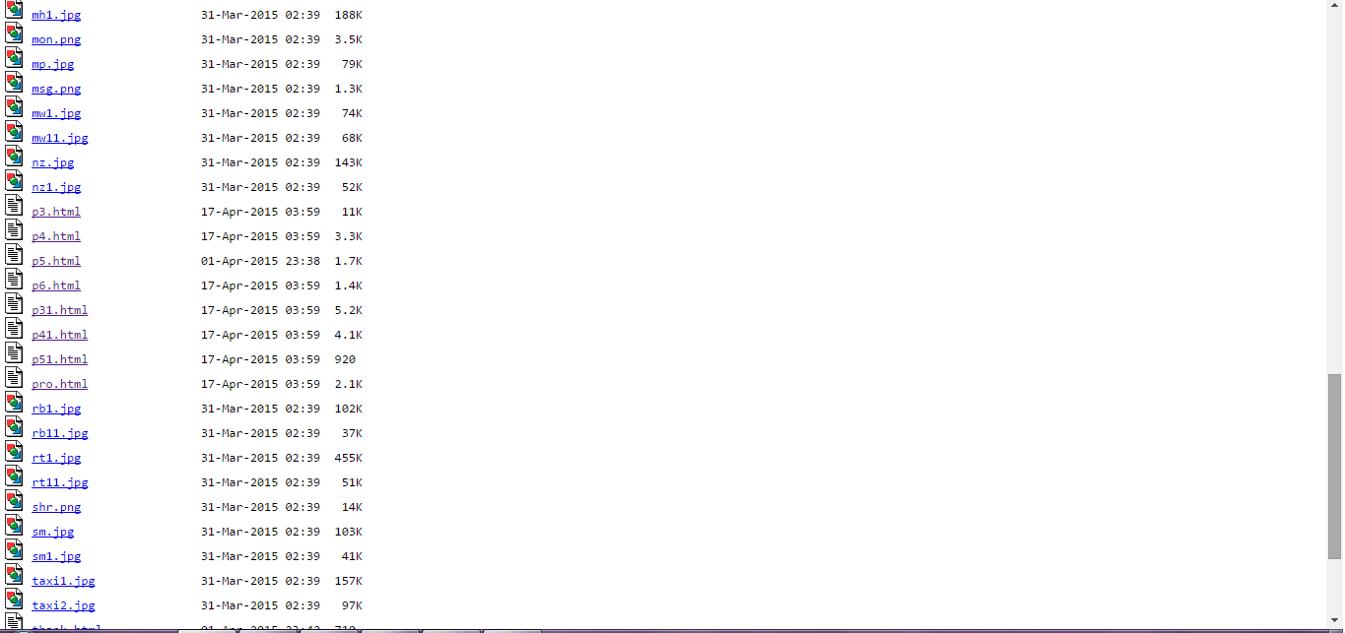

5.2 ERROR HANDLING AND VALIDATIONS

* No erroneous data has been used.
* Codes used to structure the program are valid.
* Output produced is an approximated value in case of cost estimation. Map route produced is valid as it is procured from Google Maps giving accurate map views.
* No exception handling required.

#### 6

#### LIMITATIONS

* Since the project has been undertaken as an Undergraduate degree project, its current scope is limited.
* Only 5-7 locations of the city have been taken under consideration.
* Other modes of transportation are very much available in the city, but only the most common public transports have been considered in this project.
* Due to time constraint, the project was unable to be launched as a website, thus excluding a public approach and keeping it private in nature.

#### 7

#### FUTURE SCOPE

* The project can be launched as a website, giving it a global reach and making it accessible to people all around the world.
* Database could be expanded vastly, covering each and every part of the city.
* Other modes of transportations can be added as options.
* The site can hence be used to promote tourism in the city of Kolkata and attract tourists and non-residents of the city to visit in greater numbers.
* Being a web-based project, it can be converted into a mobile phone application, thus making it easily accessible to any user in current times.

#### 8

#### REFERENCES

* [www.w3schools.com](http://www.w3schools.com)
* <http://en.wikipedia.org/wiki/HTML>
* <http://en.wikipedia.org/wiki/Cascading_Style_Sheets>
* <http://en.wikipedia.org/wiki/Application_programming_interface>
* <http://en.wikipedia.org/wiki/PHP>
* <https://maps.googleapis.com/maps/api/js?v=3.exp&signed_in=true>
* <http://sourceforge.net/projects/xampp/files/XAMPP%20Windows/1.7.1/>

BOOKS:

* HTML & CSS: The Complete Reference Fifth Edition
* PHP: The Complete Reference
* JavaScript: The Complete Reference Third Edition